**Academic Listening 2019**

**Lesson 1**

**Note-taking Techniques**

In note-taking the listener has to decide the following:

Step 1 What is being said.

Step 2 What it means (how it relates to what has been said).

Step 3 Whether it is important and whether to write it down.

Step 4 How to write it in note form.

In this decision-making process, the most important part is step 3 evaluating the importance of the information. Notice that it depends on your knowledge of the topic, rather than on your knowledge of English.

Note-taking is a very personal activity and there is no single best system. There is always more than one way of representing what the speaker has said. Any note-taking system has to be flexible. But there are three basic rules that help make note-taking quicker and more efficient:

Rule 1 Be selective: decide what is important.

Rule 2 Be brief: use abbreviations and symbols.

Rule 3 Be clear: show the interrelationship between the speaker’s points.

**Using Telegraphic Language**

When you listen to a lecture, it is not possible to write down everything the lecturer says. Good note-takers are able to write down the most important information in as few words as possible. Using telegraphic language will help you do this quickly.

Telegraphic language is abbreviated language that reads like newspaper headlines. When you use telegraphic language, you usually don’t include the following:

* Articles (*a, an, the*)
* The verb *to be* and other linking verbs
* Prepositions and pronouns

Look at this example of telegraphic language:

**Original sentence**

The first topic I will discuss is the large increase in the number of students who attend college today compared to the past. There has been a large increase of both male and female students.

**Telegraphic language**

*Topic 1: large incr. in N° of Ss in college today compared to past: ♂ & ♀*

Notice that the note-taker has also used abbreviations and symbols. Using telegraphic language together with symbols and abbreviations will help you to become a good note- taker.

**Using symbols and abbreviations**

The quantity of your notes depends partly on individual preferences and the ability to write fast, but mainly on your knowledge of the topic being talked about. It is usually not necessary, or even useful, to try to record every word that is said. Nevertheless, if you are going to take notes efficiently, you will want to save yourself as much writing as possible, and this is where the use of symbols and abbreviations comes in. One obvious point, but one that is easy to forget in taking notes under pressure of time, is to use only symbols and abbreviations that you will be able to remember when you come to revising your notes some time later. Because your notes will be shared in class and the test will be marked by your teacher, it will be wise to come to an agreement in the use of symbols and abbreviations within this programme.

***Task 1***

*a) Write in the meaning alongside each of the symbols in the table. Add any symbol you think can be useful.*

|  |  |
| --- | --- |
| ***Symbol*** | ***Meaning*** |
| **** |  |
| **** |  |
| **** |  |
| **+** |  |
| **** |  |
| **** |  |
| **** |  |
| **** |  |
| **** |  |
| **?** |  |
|  |  |
| **!** |  |
| **** |  |
|  |  |
| **** |  |
| **&** |  |
| **** |  |
| ❑ |  |
| *♀* |  |
| *♂* |  |
|  |  |

*(Source: Lynch, 2004; Sanbria,2004 & Wallace, 2004)*

*b) What do these abbreviations mean? As we proceed through the program, we will add more abbreviations useful for the topics we will be dealing with.*

|  |  |
| --- | --- |
| ***Abbreviation*** | ***Meaning*** |
| ***e.g.*** |  |
| ***i.e.*** |  |
| ***etc.*** |  |
| ***N.B.*** |  |
| ***cf.*** |  |
| ***v.v.*** |  |
| ***imp*** |  |
| ***Int’l*** |  |
| ***fut*** |  |
| ***prob*** |  |
| ***bt*** |  |
| ***ess’l*** |  |
| ***est*** |  |
| ***pro*** |  |
| **con** |  |
| ***incr.*** |  |
| ***S*** |  |
|  |  |

*(Source: Lynch, 2004; Sanbria,2004& Wallace, 2004)*

**Highlighting**

This strategy emphasises the major points in a dramatic way, through **colour**, underlining, CAPITAL LETTERS, Initial Capitals, BIG WRITING, **bold writing**, **\***stars**\***, boxes circles and so on. The sky is the limit in thinking of ways to highlight (Oxford, 1990).

**Organising Input**

With reference to rule 3 *“Be clear”* the relationship between ideas in a lecture are important and notes need to reflect them. There are many different ways to take notes, the simplest and most common form being that of raw notes, which are unstructured and untransformed. For raw notes to become useful, learners need to go back immediately (before they forget what was said) and organise the notes using a different system. A better way is to use the *shopping list* or *T-formation* as the very first step, omitting the raw notes. The advantage of using one of these formats initially is that they help learners organise what they hear while they are hearing it, thus increasing the original understanding and the ability to integrate new information with the old.

**The *shopping list format*** is extremely simple, but it does impose some sort of order and organisation on the spoken material. It involves writing down information in clusters or sets that have internal consistency or meaning. Let us see an example:

***Sustainable development***

*Definition:* SD *considers others’ needs*

*Models: 3 pillar-model: 1.economy, 2.ecology, 3.society*

*Actions: RE*

**The *T-formation format*** is similar in intent to the shopping list format, but it allows learners to use the space on the paper in a more effective way. First draw a large T on a piece of paper, taking up the whole sheet. Then write the main theme or title on the top line (the crossbar of the T). On the left side of the vertical line, write the basic categories or topics that have been discussed; on the right side of the vertical line, write details, specific examples, comments or follow-up questions. Let us see an example.

***Sustainable development***

|  |  |
| --- | --- |
| *Definition*  *Models*  Actions | SD considers others’ needs  *3 pillar-model: 1.economy*  *2.ecology*  *3.society*  *RE* ** ***fossil fuels* |
|  |  |

For the time being, these two examples are enough to start organising audio input.

**Lecture Internal Structure**

**Identifying discourse markers**

One of the most useful ways to understand a spoken or written input is to be aware of the way it is structured or organised. Listening to a lecture, for example, is a bit like finding yourself in an area that is not known to you, but which you have to find your way through. Being aware of the structure of the input is like being given a map of the area you are much less likely to get lost! We will be discussing the ways in which inputs are structured later, but we will start at a lower level by looking at discourse markers. If the structure is a map, discourse markers are like signposts, which speakers and writers use to point out the direction in which their argument is heading. They serve as signals for the meaning and structure of the lecture, text, etc. They tell us how ideas are organised. So it is very important to be on the lookout for them (see Table 1).Different discourse makers have different functions. Let us see some examples.

Table 1

|  |  |
| --- | --- |
| **Functions of discourse markers** | |
| 1. The discourse makers may be used for LISTING, for example:  firstly secondly  in the first place my next point is  another (issue…) last/finally | 6. They may be used to indicate how important something is, That is as a mark of EMPHASIS:  It is worth noting…  I would like to direct your attention to…  A key/crucial issue is… |
| 2. They may be used to show the CAUSE AND EFFECT relationship between one idea and another:  so because  therefore since  thus (we see…) | 7. They may be used to rephrase what has already been said, or to introduce a DEFINITION:  in other words to put it another way  by this I mean that is to say  let me put it this way |
| 3. They can indicate that the speaker is going to illustrate his/her ideas by giving an EXAMPLE:  for instance let’s take…  for example an example/instance of this (is…) | 8. Speakers often have a number of related points to present, so they use discourse markers to show that they are adding another related idea (ADDITION):  in addition furthermore  as well I may add that  not only…but also moreover |
| 4. They may introduce an idea which runs against what has been said, or is going to be said (CONTRAST):  but and yet  nevertheless although  on the other hand however  whereas despite | 9. They may be used to express CONDITION:  if assuming that  unless on condition that  provided providing |
| 5. They may be used to express a TIME RELATIONSHIP:  then previously  next while  after that when | 10. A very important kind of discourse marker to look out for is one which shows that the speaker is about to sum up her/his message, or part of it (SUMMARY):  to summarise  if I can just sum up  it amounts to this  What I have been saying is this  the gist/essence/core of my argument is… |

Source:Wallace 2004.

***Task 1***

*For each of the following functions, think about which note-taking techniques (such as symbols, abbreviations, layout, underlining, highlighting and use of capital letters)**might be useful to you when taking notes from an input that uses these functions. Work in pairs. Compare your choices with other students’.*

|  |  |
| --- | --- |
| ***Discourse function*** | ***Possible note-taking strategy*** |
| *1. LISTING* | *Use numbers (1,2,3,…); Take new line for each item in list.* |
| *2. CAUSE AND EFFECT* |  |
| *3. EXAMPLE* |  |
| *4. CONTRAST* |  |
| *5. TIME RELATIONSHIP* |  |
| *6.EMPHASIS* | *Use block capitals; Underline; Circle word/s.* |
| *7. REPHRASE/DEFINITION* |  |
| *8. ADDITION* |  |
| *9. CONDITION* |  |
| *10. SUMMARY* |  |

**Lecture organisation**

Now, let us see how a lecture is generally organised.

* The lecturer should start with an overview or **preliminary summary** of the main points of the lecture.
* Then having thus prepared the audience on what to expect, the lecturer should deliver the **main body** of the lecture.
* When this has been done, the lecturer should in the last few minutes review the main points of the lecture in a **final summary**.

Not all lecturers, unfortunately for the listeners, follow this kind of structure. Some like to begin with an anecdote intended to amuse the audience or catch interest. Some like to conclude with one important point that they want their audience to think about. Others will helpfully show the structure of their talk with an overhead transparency, handout or PowerPoint presentation. Whatever method of presentation is used, it is very important for the listener to try to figure out not only what the information is but also how it is organised.

**Task 2**

**Pre-listening Tasks**

1. ***Vocabulary: Find the definition for each word.***

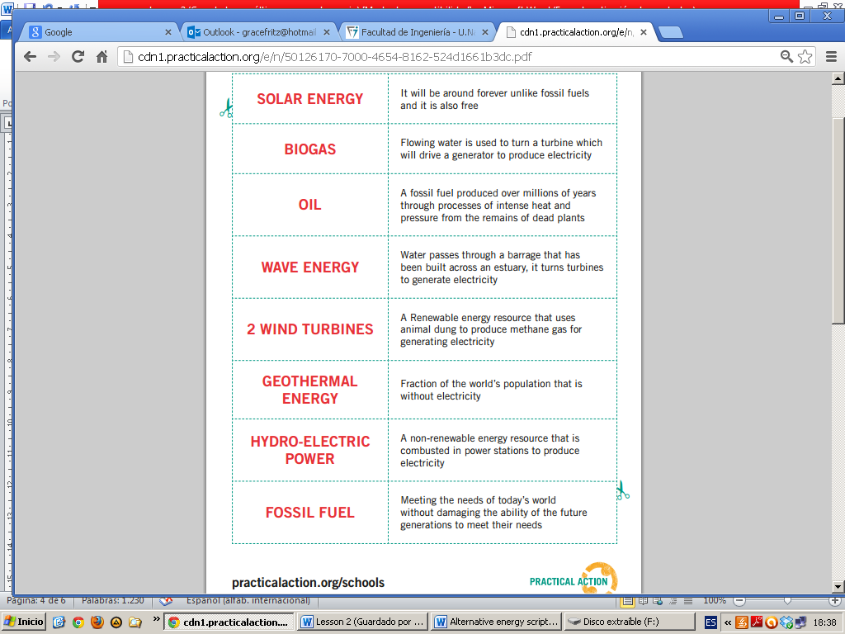 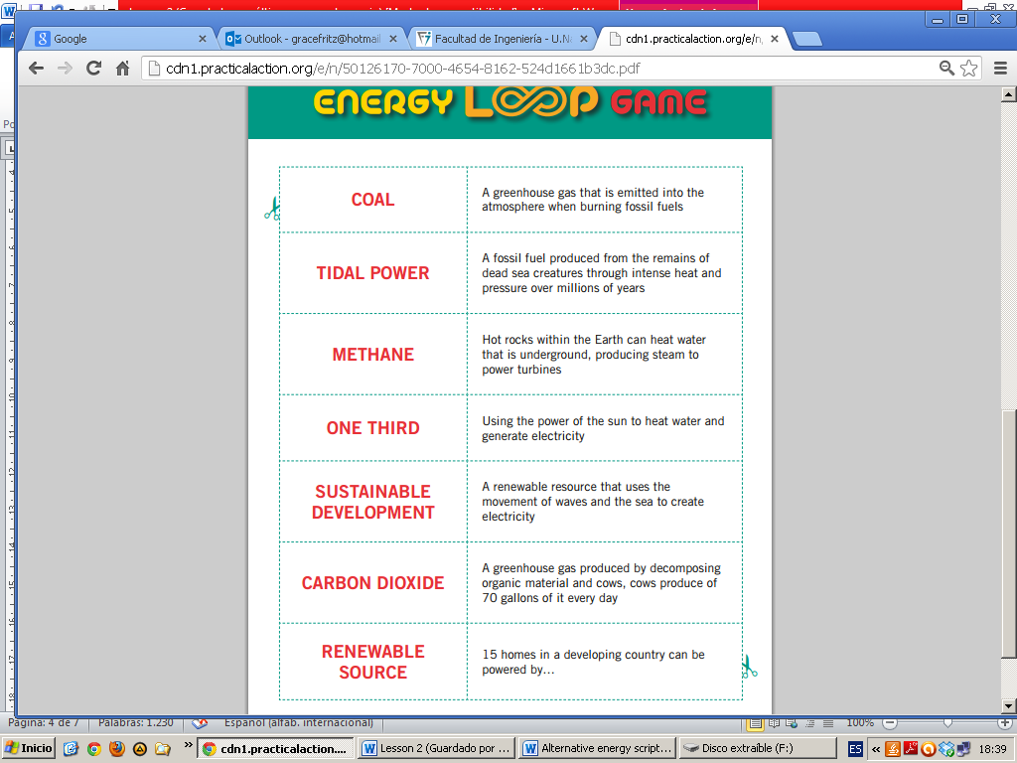

Taken from: practicalaction.org/schools

1. ***Discussion***
2. What does renewable energy imply? What are the benefits of renewable energy sources?
3. What do you know about alternatives to fossil fuels? Discuss in groups their benefits.
4. Working with a partner, make a list of the possible renewable energy sources that can be applied in our region.

***First listening***

You will see a video about Renewable Energy. As you listen make notes on the main points. Use telegraphic language, conventional symbols and abbreviations. Make a conscious effort to pay attention to discourse markers and listen out for definitions and explanations of technical terms.

***Second listening***

The teacher will now play the video a second time. Add details to your notes where necessary to show the relative importance of the points. You can use highlighting techniques for the purpose.

***After listening***

A) After listening and watching the video, compare the content of your notes with those of another student. Ask yourself the following:

* Have you included the same information?
* If you missed any points, has your partner made notes on them?
* If there were points (words or sections) that neither of you could understand, can others in the class help?

Next, compare the form of your notes. For this you will need to put them side-by-side. Look for differences between the ways in which you have used:

* abbreviations
* symbols
* telegraphic language
* spatial layout ( columns )
* emphasis (such as underlining and capital letters).

B) Then, compare your notes with the outline which will be shown on the board. Did you cover the most relevant items?