Paragraph writing: Cause & Effect | 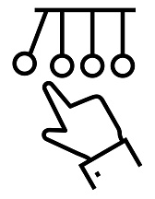
What is a cause & effect paragraph?
A cause-and-effect paragraph is a type of expository paragraph that explains why something happens (causes) and what happens as a result (effects).
- Causes: The reasons or factors that produce an event or situation.
- Effects: The results or consequences of an event or situation.
Compare-Contrast Paragraphs
A cause-and-effect paragraph answers two main questions:
- Why does something happen? (Cause)
- What happens as a result? (Effect)
Structure of a compare-contrast paragraph:
A cause-and-effect paragraph generally follows this structure:
- Topic sentence: Introduces the topic and states the main cause, effect, or relationship between them.
- Supporting sentences: Explain the causes and/or effects in detail, providing examples, explanations, or evidence.
- Concluding sentence: Summarizes the main idea or emphasizes the relationship between causes and effects.
A cause-and-effect paragraph can be organized in three different ways:
- Causes → Effects: Explains why something happens and its consequences.
- Effects ← Causes: Focuses on the results of a particular event or situation.
- Cause ↔ Effect: Explains the relationship between causes and effects.
Transitions for Cause & Effect Writing
• because / since / as • because of + noun phrase • due to + noun phrase • so • therefore • as a result • consequently • for this reason

Class Activity

TASK 1 — MATCHING
Match each cause (1–8) with the most appropriate effect (a–h). Write the letter in the box.
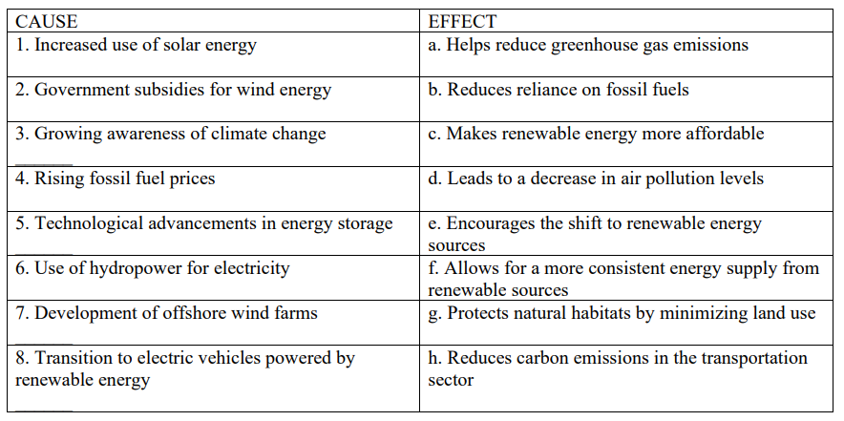

TASK 2 — CLUSTERING
Complete the organizer with possible causes and effects.
NATURAL RESOURCE DEPLETION
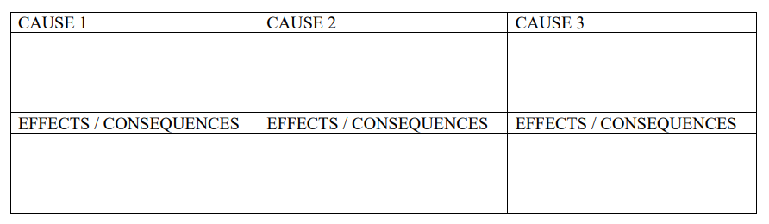

TASK 3 - READING

NATURAL RESOURCE DEPLETION
Since some natural resources have been polluted and others are starting to run out, it is sensible to become environmentally aware. If we go green, the Earth’s resources can last longer and consequently can meet the needs of future generations. There are several reasons for the depletion of natural resources at a quick pace. One reason for resource reduction is the increase in the world’s population. World population has doubled in the last fifty years, and everybody needs food, clothing and shelter. Another reason for the scarcity of essential materials is the excessive or unnecessary use of resources. Consumerism is economically manifested in the chronic purchasing of new goods and services, with little attention to their true need, durability, product origin or the environmental consequences of manufacture and disposal. And last but not least, fresh water is a worldwide scarce resource that needs conservation. Industries, such as mining and mineral processing are polluting this vital liquid, disregarding people, animals and plants that depend on it for their existence. If we don’t think green, we will run short of natural resources in our lifespan, and what shall we do then?

TASK 4 - READ & ANALYZE

1. What is the main environmental problem described in the text?
2. Identify 2 causes of natural resource depletion.
3. What are 2 effects or consequences mentioned in the text?
4. Find 2 cause/effect linking expressions.
5. What action does the writer suggest?

TASK 5 - BUILD YOUR PARAGRAPH

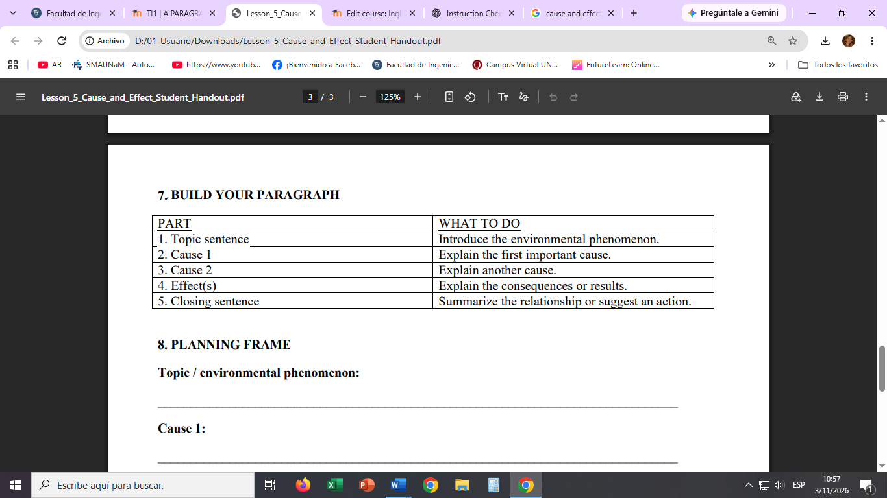

Write a cause/effect paragraph about an environmental phenomenon. Use a clear topic sentence, at least two causes, relevant effects, and cause/effect linking expressions.

