Paragraph writing: Process description | 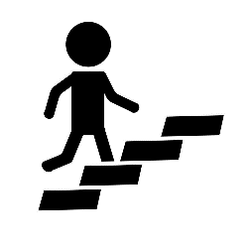
What is a process paragraph?
When you explain how to do something or how something happens, you use a process to talk about the steps or events. A process paragraph is a group of sentences that tells this sequence. A process paragraph consists of a series of connected steps. The steps must be logical and are often chronological in order. You can use time words and transition expressions to make the sequence of events or actions clear. Process writing is especially important when you want to explain the steps necessary to complete a task. Process paragraphs usually demonstrate how to do something.
Process Paragraphs
Process paragraphs explain: HOW something works or HOW something happens
A good process paragraph:
✓ follows a logical order
✓ presents each step clearly
✓ uses sequencing expressions
✓ includes the necessary stages

Structure of a process description paragraph:

Topic Sentence → Process Steps → Closing Sentence

Transitions for Process Writing
• Useful transitions for process writing are: first, next, then, firstly, secondly, finally, after that, etc.
SEQUENCING EXPRESSIONS
BEGINNING  First  First of all  Initially | MIDDLE  Next  Then  After that  Subsequently | END  Finally  Eventually  As a result,

Class Activity

- WIND ENERGY

VOCABULARY: KNOW YOUR COMPONENTS

Match each word with its definition.
1. Rotor  2. Gearbox  3. Generator  4. Transformer  5. Shaft | A. Increase the voltage  B. Produce electricity  C. Transfer energy from the wind  D. Make the rotation faster  E. Connect moving parts
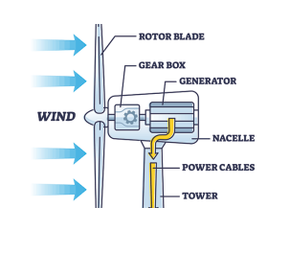
Complete the sentences with the correct word.
1. The ______ spins when the wind blows.
2. The ______ increases the speed of rotation.
3. The ______ produces electricity.
4. The ______ raises the voltage.
5. The ______ connects moving parts.

HOW DOES A WIND TURBINE WORK?
Number the stages 1–4.
☐ Send Power Out
☐ Catch the Wind
☐ Generate Power
☐ Speed Up the Rotation

Now think like an engineer. The turbine cannot generate electricity until it has been installed. What happens first? So, let´s think about:
• Site
• Foundation
• Tower
• Nacelle
• Rotor & Blades
• Electrical System

INSTALLATION VOCABULARY
Match the action with the meaning.
1. Prepare  2. Install  3. Assemble  4. Connect  5. Secure  6. Inspect | A. Check carefully  B. Put equipment in the correct position  C. Make something ready  D. Join two systems or components  E. Put parts together  F. Make something stable or safe

How Is a Wind Turbine Installed?
The installation of a wind turbine involves several important stages to ensure that the structure is stable, safe, and ready to operate. First, a suitable site is selected, taking into account wind conditions and ground stability. Then, the ground is prepared, and a strong foundation is built to support the weight of the wind turbine. Next, the tower is installed and securely fixed to the foundation. After that, the nacelle, which contains the main mechanical and electrical components, is lifted and installed on top of the tower. Subsequently, the rotor and blades are assembled and attached to the nacelle. The electrical system is then connected to ensure that the turbine can transmit the electricity it generates. Finally, all the components and connections are carefully inspected to check that the structure is stable and the equipment operates safely. Once the installation process is complete, the wind turbine is ready to start operating and converting wind energy into electricity.
Answer the following questions based on the process described in the paragraph.
- What process is described in the paragraph?
- Which sentence is the topic sentence?
- How many steps are mentioned in the process?

- SOLAR POWER

VOCABULARY
Match each word with its function.
1. Solar panel  2. Charge controller  3. Battery  4. Inverter  5. Electricity  6. Current | A. Stores electricity  B. Energy used by devices  C. Movement of electricity  D. Regulates electrical flow  E. Captures sunlight  F. Converts DC into AC
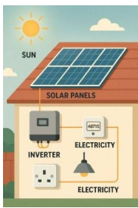

UNDERSTAND THE PROCESS
1. What happens first?
2. What is the function of the inverter?
3. Why is the battery necessary?

INPUT → PROCESS → OUTPUT
Sunlight → System → Electricity

HOW DOES A SOLAR POWER SYSTEM WORK?

Read the paragraph and match each paragraph function in Column A with the corresponding sentence in Column B. Write the correct letter next to each number.

A solar panel system converts sunlight into electricity for homes and buildings. First, the solar panel captures energy from the sun and produces direct current (DC) electricity. Next, the electricity flows to the charge controller. The controller regulates the flow of electricity and protects the battery. Then, the electricity follows one of two paths. It can go directly to the lights, or it can be stored in the battery for later use. After that, the battery supplies electricity when there is little or no sunlight. The electricity passes through the controller before it reaches the lights. Finally, the controller manages the entire system. It stops charging the battery when it is full and prevents the battery from sending power when it is empty. As a result, the system stores and delivers electricity safely and efficiently whenever it is needed.

Column A – Paragraph structure | Column B – Sentences
- ___ Topic sentence  - ___ Supporting detail 1: First stage of the process  - ___ Supporting detail 2: Function of the controller  - ___ Supporting detail 3: Storage and delivery of electricity  - ___ Supporting detail 4: Final function of the controller  - ___ Concluding sentence | A. “After that, the battery supplies electricity when there is little or no sunlight. The electricity passes through the controller before it reaches the lights.”  B. “A solar panel system converts sunlight into electricity for homes and buildings.”  C. “Finally, the controller manages the entire system. It stops charging the battery when it is full and prevents the battery from sending power when it is empty.”  D. “First, the solar panel captures energy from the sun and produces direct current (DC) electricity.”  E. “As a result, the system stores and delivers electricity safely and efficiently whenever it is needed.”  F. “Next, the electricity flows to the charge controller. The controller regulates the flow of electricity and protects the battery. Then, the electricity follows one of two paths. It can go directly to the lights, or it can be stored in the battery for later use.”

