A Paragraph Writing Course  2019-2021 |   http://www.smartwritinghandbook.com/
Lesson 1
The Rhetorical Situation

Goal: Learn about the rhetorical situation
Objectives:
- Watch slides about the rhetorical situation
- Observe how diverse kinds of texts have their own rhetorical situations
- Design a rhetorical situation and share it with the class

The Rhetorical Situation
“Rhetoric” implies that whenever humans communicate with other humans, they seek to elicit any number of responses ranging from understanding to emotional reaction to agreement to enlightenment or any one of almost limitless reactions. At its most basic, communication is the set of methods whereby humans attempt to identify with each other.
Elements of a Rhetorical Situation
Every rhetorical situation has four basic components: an author, an audience, a text of some sort, and a context in and through which each situation occurs. All of these terms (author, audience, text, and context) are fairly loose in their definitions and all of them affect each other. Also, all of these terms have specific qualities that affect the ways that they interact with the other terms.
Text
Usually, the word “text” refers to a written or typed document. In terms of a rhetorical situation, however, “text” means any form of communication that humans create. Whenever humans engage in any act of communication, there is a text that serves as the vehicle for communication. Three basic factors affect the nature of each text: the medium of the text, the tools used to create the text, and the tools used to decipher the text.
Medium of a Text
Texts can appear in any kind of medium, or mechanism for communicating. The plural of medium in this sense is media. Various media affect the ways that authors and audiences communicate. Consider how these different types of media can affect how and what authors communicate to audiences in various rhetorical situations: hand-written, typed, computer-generated, audio, visual, spoken, verbal, non-verbal, graphic, pictorial, tactile, with words, or without words (there are many others, of course). Some varied specific examples of media could include a paper, a speech, a letter, an advertisement, a billboard, a presentation, a poster-board, a cartoon, a movie, a painting, a sculpture, an email, a Twitter tweet, a Facebook post, graffiti, a conversation (face-to-face, on a cell phone, via text messages) . . . this list is nearly endless.

Tools to Make a Text
Every text is made with tools that affect the structure and content of a text. Such tools could be physical tools that range from very basic (such as the larynx, throat, teeth, lips, and tongue necessary for verbal communication) to very complex (such as a laptop computer with graphic-manipulating software). These tools could also be more conceptual tools that range from simple (such as implementing feedback from an instructor) to more complicated (such as implementing different kinds of library and primary research). The tools of communication often determine the kinds of communication that can happen in any given rhetorical situation.

Tools to Decipher a Text
Likewise, audiences have varied tools for reading, viewing, hearing, or otherwise appreciating various texts. These could be actual physical tools that would likewise range from very basic (like the eyes and reading glasses necessary to read) to very complex (like a digital projector and screen to view a PowerPoint presentation). Or they could be conceptual tools that could range from simple (childhood principles learned from parents) to more complicated (a master’s degree in art). The tools that audiences have at their disposal affect the ways that they appreciate different texts.
For further information on the rhetorical situation visit: http://owl.english.purdue.edu/owl/resource/625/01/

Task 1: Identify the six basic components in these different rhetorical situations (Writer, Purpose, Audience, Topic, Context & Culture):

An expert is giving a lecture on Renewable Energy Sources in Misiones at JIDeTEV2019 FI- UNaM.
- A speech is being delivered by a candidate who is running for President next October.

- A math teacher is telling his/her students that they will be having an exam the following week.

- A businessman is writing an e-mail to a manufacturing company in order to purchase items from an online catalog.

Task 2: Work in pairs. Design a rhetorical situation identifying: Speaker/Writer, Purpose, Audience and Topic.

Lesson 2  Paragraph Structure | 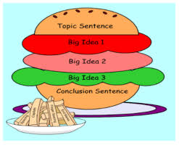  http://exchange.smarttech.com/
Goal: Gain knowledge of paragraph structure
Objectives:
- Learn how to achieve well-formed paragraphs
- Identify the parts of a paragraph and label them

What is a paragraph?
A paragraph is a collection of related sentences dealing with a single topic. To be as effective as possible, a paragraph should contain each of the following: Unity, Coherence, a Topic Sentence, and Adequate Development. As you will see, all of these traits overlap. Using and adapting them to your individual purposes will help you construct effective paragraphs.

1. Unity:
The entire paragraph should concern itself with a single focus. If it begins with a focus or major point of discussion, it should not end with another or wander within different ideas.

2. Coherence:
Coherence is the trait that makes the paragraph easily understandable to a reader. You can help create coherence in your paragraphs by creating logical bridges and verbal bridges.
- logical bridges:
The same idea of a topic is carried over from sentence to sentence;
Successive sentences can be constructed in parallel form.
- verbal bridges:
Key words can be repeated in several sentences;
Synonymous words can be repeated in several sentences;
Pronouns can refer to nouns in previous sentences;
Transition words can be used to link ideas from different sentences.

*Remember to:
- be consistent in point of view, verb tense, and number.; and
- use transition words or phrases between sentences and between paragraphs.

Some useful Transition devices
- To show addition: again, and, also, besides, equally important, first (second, etc.), further, furthermore, in addition, in the first place, moreover, next, too
- To give examples : for example, for instance, in fact, specifically, that is, to illustrate
- To compare: although, and yet, at the same time, but, despite, even though, however, in contrast, in spite of, nevertheless, on the contrary, on the other hand, still, though, yet
- To summarize or conclude : all in all, in conclusion, in other words, in short, in summary, on the whole, that is, therefore, to sum up
- To show time: after, afterward, as long as, as soon as, at last, before, during, earlier, finally, formerly, immediately, later, meanwhile, next, since, shortly, subsequently, then, thereafter, until, when, while
- To show place or direction: above, below, beyond, close, elsewhere, farther on, here, nearby, opposite, to the left (north, etc.)
- To indicate logical relationship: accordingly, as a result, because, consequently, for this reason, hence, if, otherwise, since, so, then, therefore, thus

3. A topic sentence:
A topic sentence is a sentence that indicates in a general way what idea or thesis the paragraph is going to deal with. Although not all paragraphs have clear-cut topic sentences, and despite the fact that topic sentences can occur anywhere in the paragraph (as the first sentence, the last sentence, or somewhere in the middle), an easy way to make sure your reader understands the topic of the paragraph is to put your topic sentence at, or near the beginning of the paragraph. (This is a good general rule for less experienced writers, although it is not the only way to do it).

4. Adequate development
The topic (which is introduced by the topic sentence) should be discussed fully and adequately. Again, this varies from paragraph to paragraph, depending on the author's purpose, but writers should beware of paragraphs that only have two or three sentences. It's a pretty good bet that the paragraph is not fully developed if it is that short.

Paragraph Structure
Most paragraphs in an essay have a three-part structure--introduction, body, and conclusion. You can see this structure in paragraphs whether they are narrating, describing, comparing, contrasting, or analyzing information. Each part of the paragraph plays an important role in communicating your meaning to your reader.
• Introduction: the first section of a paragraph; should include the topic sentence and any other sentences at the beginning of the paragraph that give background information or provide a transition.
• Body: follows the introduction; discusses the topic sentence, using facts, arguments, analysis, examples, or other information.
• Conclusion: the final section; summarizes the connections between the information discussed in the body of the paragraphs and the paragraph's topic sentence.

(Adapted from: http://owl.english.purdue.edu/owl/resource/606/2/)

Figure 1, below, shows some types of organization patterns in which paragraphs are organized.
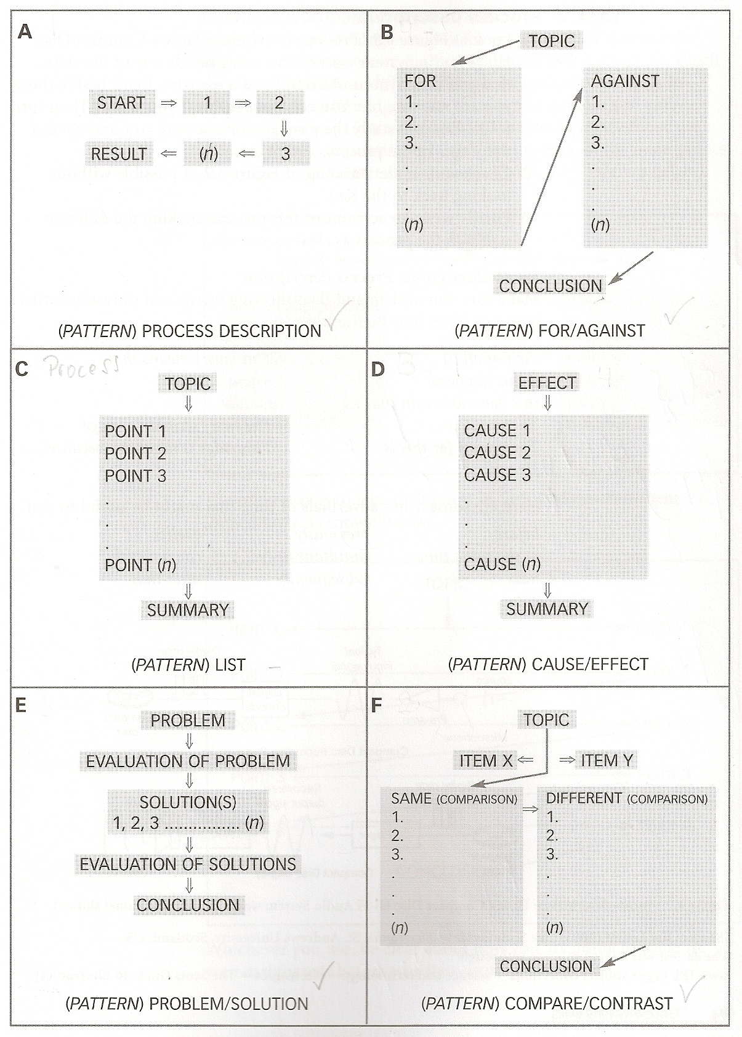
Figure 1. Frames and their Organization Patterns. Source: Wallace (2004)

Paragraph Structure Tasks
1. Read the paragraph below. Then choose the best option for the title.
- Sustainable Engineering  - An introduction to Sustainability  - Environmental Management  Environmental and natural resource issues have gained increasing prominence in the latter half of the 20th century and the beginning of the 21st century. Furthermore, growing populations and affluence, around the globe, have put increasing pressure on air and water, arable land, and raw materials. Concern over the ability of natural resources and environmental systems to support the needs and wants of global populations, now and in the future, is part of an emerging awareness of the concept of sustainability which involves the environment, society, and economy. Moreover, its goal is to enable all people throughout the world to satisfy their basic needs and enjoy a better quality of life, without compromising quality of life for future generations. Hence, professional engineers are required to play a leadership role in sustainable development, overcoming global challenges, such as depletion of resources, environmental pollution and damage to ecosystems.  Adapted from: http://www.engc.org.uk/about-us/sustainability and http://www.informit.com/articles/article.aspx?p=1828432 | 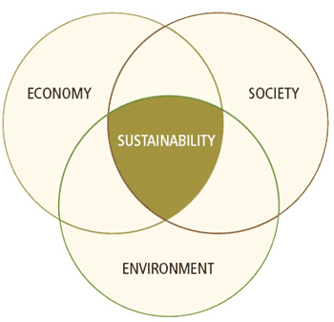

2. What is the topic sentence of the paragraph?

- Environmental and natural resource issues have gained increasing prominence in the latter half of the 20th century and the beginning of the 21st century.
- Concern over the ability of natural resources and environmental systems to support the needs and wants of global populations, now and in the future, is part of an emerging awareness of the concept of sustainability which involves the environment, society, and economy
- Hence, professional engineers are required to play a leadership role in sustainable development, overcoming global challenges, such as depletion of resources, environmental pollution, rapid population growth and damage to ecosystems.

3. What sentences would not fit in the paragraph above?

- Solar hot water heaters are especially useful for businesses that utilize large quantities of hot water.
- More than 85% of the world’s current energy needs are met through fossil fuels such as coal, oil and natural gas.
- There are various strategies that can be used so as to obtain better results.
- Engineers in the 21st century will need to design for energy efficiency and low environmental emissions.
- A profitable business is much more likely to remain stable and continue to operate from one year to the next.
- Acid rain can have harmful effects on plants, aquatic animals and infrastructure.

http://www.energy4me.org/energy-facts/energy-sustainability/

4. Tick the following words/phrases under the corresponding term that exemplifies the concept of sustainability.

 | Sustainability
 | Society | Environment | Economy
ecosystems
global populations
natural resources
affluence
arable land
basic needs

5. Write the 3 transitional devices that were used in the paragraph.

…………………………………..
…………………………………..
…………………………………..

6. What is the logical order presented in the paragraph?

A | B | C
1. Environmental importance 2.Concept of sustainability  3.Sustainable engineering | 1. Concept of sustainability  2. Sustainable engineering  3.Environmental importance | 1.Sustainable engineering  2. Environmental importance  3. Concept of sustainability

