Paragraph Structure Task

1. Read the paragraph below. Then choose the best option for the title.
- Sustainable Engineering  - An introduction to Sustainability  - Environmental Management  Environmental and natural resource issues have gained increasing prominence in the latter half of the 20th century and the beginning of the 21st century. Furthermore, growing populations and affluence, around the globe, have put increasing pressure on air and water, arable land, and raw materials. Concern over the ability of natural resources and environmental systems to support the needs and wants of global populations, now and in the future, is part of an emerging awareness of the concept of sustainability which involves the environment, society, and economy. Moreover, its goal is to enable all people throughout the world to satisfy their basic needs and enjoy a better quality of life, without compromising quality of life for future generations. Hence, professional engineers are required to play a leadership role in sustainable development, overcoming global challenges, such as depletion of resources, environmental pollution and damage to ecosystems.  Adapted from: http://www.engc.org.uk/about-us/sustainability and http://www.informit.com/articles/article.aspx?p=1828432 | 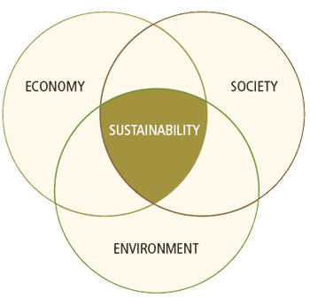

2. What is the topic sentence of the paragraph?

- Environmental and natural resource issues have gained increasing prominence in the latter half of the 20th century and the beginning of the 21st century.

- Concern over the ability of natural resources and environmental systems to support the needs and wants of global populations, now and in the future, is part of an emerging awareness of the concept of sustainability which involves the environment, society, and economy.

- Hence, professional engineers are required to play a leadership role in sustainable development, overcoming global challenges, such as depletion of resources, environmental pollution, rapid population growth and damage to ecosystems.

