**English for Occupational Purposes**

**English for occupational purposes** (EOP) refers to the specific ways **English** is used in different work and professional situations. We will focus on possible scenarios where you may encounter the need to use English in your near future:

* Job hunting
* Resume writing
* Job interview
* Presenting a product or service

**Job hunting**

Have you thought about the type of job you would like after graduating? Do you have a specific job in mind?

Think about a job that you would like to have. A job that when the alarm clock goes off you say: “Hurray! I am so happy that I can go to work!!!”

1. **Which is your ideal job?**

What makes a job ideal for you will depend on a whole range of factors and needs that are unique to you. These include:

1. What you like to do

2. What motivates you in work (Read pdf file for more information)

3. How you like to work

4. How much, when and where you want to work

5. Working with people that think and behave in a similar way to you

1. **Where can you find information about job openings or vacancies?**

Companies usually post job ads in the newspapers and magazines, shop windows and notice boards in your local area and university. You may also find job adverts in websites and online recruitment agencies, professional networking platforms, discussion forums and even social media sites.

1. **What should you pay attention to in job ads?**

Make sure you read the advertisement carefully, so you have a clear idea of the basic nature of the position and what the employer is looking for. Then ask yourself these central questions:

* Would I like this job?
* Does it pay well enough?
* Is the location convenient?
* Would it be a step forward in my career?
* Is there any single task mentioned in the ad that I would be either unable or unprepared to do?

If the ad is clear and informative, it should provide the answers to these questions and give you the basis for deciding whether to go ahead and apply or move on to the next one.

1. **Are you suitable for the job? Do you have the necessary skills?**

When considering a job it is important to think about your personal skills. Can you make a list of your skills?

Read the list about job skills that employers seek for today. (Read word document titled Job skills)

**Homework**

Share the job advert you have found of your ideal job by posting the image or link.

**Resume writing**

After finding a suitable job advert, the next step is to write a Curriculum Vitae (CV) or Resume. A **CV** is a a longer academic diary that includes all your experience, certificates, and publications; whereas, the **resume** is a one page summary of your personal, professional, educational and work qualifications and skills relevant to the job you are applying to.

1. Why do you need a resume?

Most job adverts mention the requirement of a resume in order to inform prospective employers of your qualifications and experience for the job position. If your resume provides a good impression and interests the employer, you will get a job interview.

1. Are there different types of resumes?

There are different formats of resumes. Some job openings require them to be completed online and others need to be written and sent. The main types are:

|  |  |
| --- | --- |
| Chronological | * Most traditional format. * Lists work experience by dates in reverse chronological order (most recent first). * Does not highlight main skills and qualifications. * Useful when:   -You have consistent work history with growth and achievements.  -No gaps in employment and staying in the same field. |
| Functional/  Skills-Based | * Groups your qualifications around skill headings. * Highlights major areas of accomplishment, strengths, and abilities in order of importance to this particular job/employer. * Actual work history is minimized. * Useful when:   -Changing careers or reentering job market.  -Gaps in employment.  -Variety of different jobs. |
| Combination | * Combines the best of chronological and functional. * Includes qualifications section and may highlight key strengths. * Work history section may emphasize results instead of job duties. |

1. What information should be included in a resume?

Since a resume is a snapshot of who you are and your qualifications and experience for a position, take the time to think about yourself and plan carefully how to write these things down to convince your future employer that you are the ideal candidate for the job he or she has to offer.

The information that should be included in any well-prepared resume is divided in the following parts:

1. **Heading**

This section includes personal information about you: yourname, address, phone number and Email address. Add a profesional photograph of you, as well.

1. **Job Objective**

It is a short statement that tells the employer what specific position you’re applying for. It should be concise and specific.

1. **Education**

In this section use reverse chronological order to name your graduate degree, school and year of graduation. You can mention your GPA (*promedio*) and honors. In case you have not completed your studies yet, you should write: Expected graduation or Projected and the possible date (see resume samples).

1. **Relevant courses and professional training**

List courses and professional training related to the job opening in this section. Include the name and any other useful information.

1. **Work Experience**

In a reverse chronological order provide a list of your work experience (full-time and part time jobs, internships, volunteer work). Write the position title, name of company, dates of employment (month & year), and place. You may also include specific responsibilities, description of the job, and accomplishments.

1. **Skills and Personal Qualities**

List your personal skills and qualities. You may divide them in categories that are related to the job.

Homework

Write your own resume. Remember to include the details seen above. See samples provided for more information.

**Job Interview**

If your resume provided a good impression, the employer will ask you to complete the following step which is the job interview.

As a general rule, a job interview is an important part of the process of applying for a job and it consists in a conversation. This exchange may range in formality from a casual conversation to a series of serious discussions between a job applicant and a potential employer or with an assortment of people working within the company.

During the job interview, the employer has the opportunity to appraise applicant’s qualifications, appearance and general fitness for the job opening. It is wise to prepare for a job interview. Here are some tips and possible questions to consider during an interview.

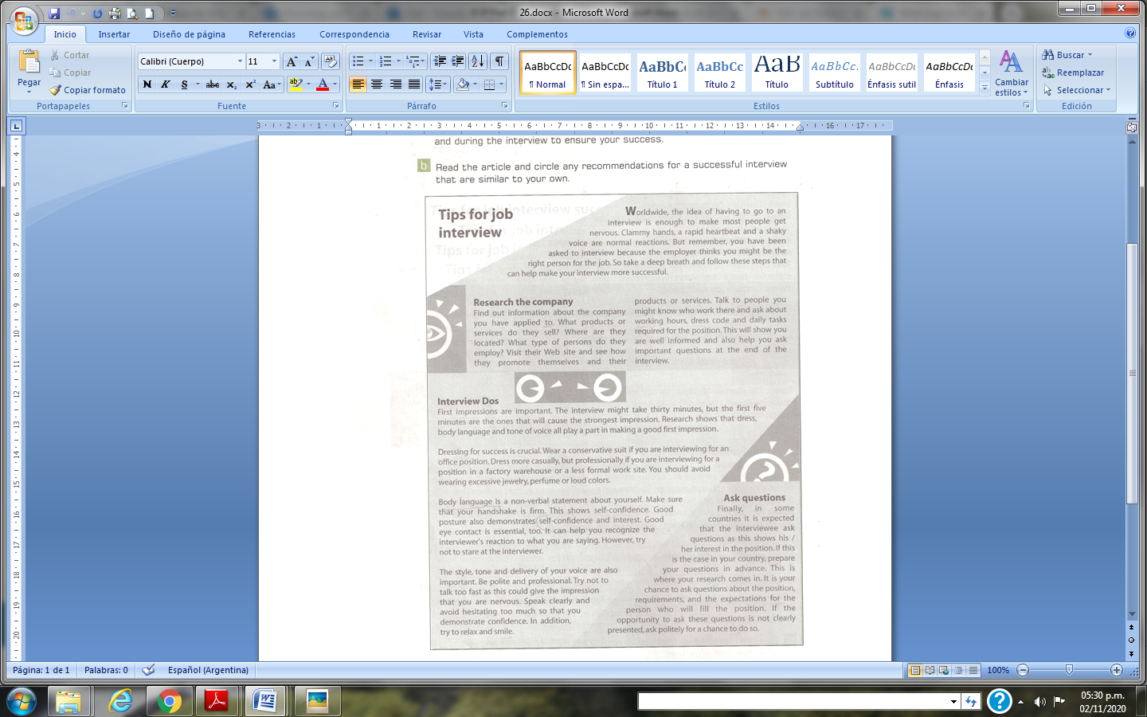

Questions you are most likely to be asked in a job interview:

1. Tell me about yourself (provide an overview of who you are as a professional).
2. What interests you about this opening? (Or why do you want to work for us?)
3. What do you know about our company so far?
4. Why did you leave your last job? (Or why are you thinking about leaving your current job?)
5. Tell me about your experience at ___. (Fill in past job.)
6. What experience do you have doing ____? (Fill in each of the major responsibilities of the job.)
7. Tell me about your strengths.
8. Tell me about a difficult time and how you overcame it?
9. 9. What salary range are you looking for? (Most lines of work have a set salary range and it would be wise to learn what this range is prior to the interview. If you are unable to obtain this information, you may want to tell the interviewer that you would work for whatever the company feels is fair, based on your qualifications and the company's standard salary level for that position. If you want to request a specific salary, be able to back up why you should get that amount - avoid stating personal reasons.)
10. What questions do you have for me? Here are 10 questions to consider asking:
11. Why is this position open?
12. What are the biggest challenges or obstacles the person in this position will face?
13. Can you describe a typical day or week in the position?
14. What would a successful first year in the position look like?
15. How will the success of the person in this position be measured?
16. Thinking back to the person whom you have seen do this job best, what made his or her performance so outstanding?
17. How would you describe the culture here?
18. How would you describe your management style?
19. Are there reservations you have about my fit for the position? (This is a great way to give yourself the chance to tackle any doubts they might have about you)
20. When do you expect to make a hiring decision?

Homework

Watch the interview clip taken from the film “The pursuit of happyness”. Then in this week´s FORUM discuss the Do´s and Don´ts for a job interview.

**Presenting a product or service**

Let´s imagine you gave a good impression in the interview and you obtain the job and you are asked to carry out a presentation of a product or service. This type of activity is common in many businesses and companies. Oral presentations are an important part of a business. Most businesses use oral presentations to discuss ideas or new business ventures.

**What is an oral presentation?**

The definition of an oral presentation is the delivery of a speech to an audience. In general, the purpose of a presentation may be to provide information, persuade the audience to accept a point of view, or encourage them to take action. An oral presentation presents subject content in an organized, concise and effective manner. Planning, writing and completing are three key elements in any oral presentation process.

**What is a product?**

A product is described as ‘a thing produced by labour or effort’. Product is also referred to ‘anything produced, or anything that can be offered to a market that might satisfy a want or need’.

**What is a service?**

A service is defined as ‘a system or an organization that provides the public with something that it needs’. It is also explained as ‘the work or the quality of work done by somebody when servicing a customer’. In simpler words, service is a form of a particular skills or help that a person is able to offer for customers but not producing goods. Just like goods, services are products which are bought and sold.

**Stages for the preparation of an oral presentation**

**1.** Plan the Presentation



**2.** Write the Presentation



## 3. Complete the Presentation

 

**Homework**

In groups of 4, you will decide on an innovative product or service to present orally. In the FORUM created for this week, you will state the name of the product or service and provide the names of the students of the group. Then work together to plan your presentation.

The weeks following, we will work on the writing and completing of the oral presentation.

The assignment needs to be checked by the teacher before the exam.