Grammar as an Emergent Process (2024)

Lesson 1
Grammaring Tasks

- Write a caption below each picture to illustrate them.

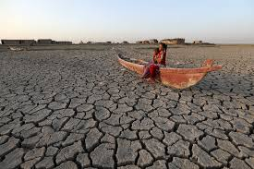
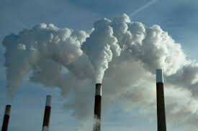
- ……………………………………………………….. 2. ……………………………………………………….

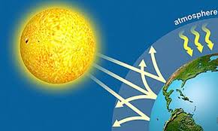
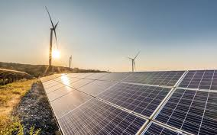

3. ……………………………………………………... 4. ………………………………………………………

Discussion
- What causes climate change?
- What will happen if deforestation continues?
- Is it possible for people to live without making any garbage?
- How was the environment different 100 years ago?
- What can you do today to help the environment?

- Write headlines for these texts.
How short can you make them without changing the sense?

1-……………………………………………………………………………………………………………………………………………
Not all pollution comes from people. When global temperatures increase by 4 degrees Celsius, harmful plant emissions and dust will also increase by as much as 14 percent, according to a new research. "We are not looking at human emissions of air pollution, because we can change what we emit," said James Gomez, UCR doctoral student and lead author of the study. "We can switch to electric cars. But that may not change air pollution from plants or dust."

2…………………………………………………………………………………………………………………………………………….
As air pollution in Stockholm has decreased, the lung capacity of children and adolescents has improved, according to a new study published in the European Respiratory Journal reports. The researchers consider the results important, since the lung health of the young greatly affects the risk of their developing chronic lung diseases later in life. When we compare the individuals living in the areas in which air quality has improved and those in which it hasn't, we find that lung function improved by a few per cent in the participants in the young adult age bracket," says Zhebin Yu from the Institute of Environmental Medicine.

3.……………………………………………………………………………………………………………………………………………
Global warming may be interacting with regional rainfall and deforestation to accelerate forest loss in the Amazon, pushing it towards partial or total collapse. New research has identified the potential thresholds of these stressors, showing where their combined effects could produce a 'tipping point' -- in which the forest is so fragile that just a small disturbance could cause an abrupt shift in the state of the ecosystem.

4…………………………………………………………………………………………………………………………………………….
Ongoing climate change driven by greenhouse gas emissions is often discussed in terms of global average warming. For example, the landmark Paris Agreement seeks to limit global warming to 1.5 degrees C, relative to pre-industrial levels. However, the extent of future warming will not be the same throughout the planet. One of the clearest regional differences in climate change is the faster warming over land than sea.

C. Here are some newspaper headlines. Expand them so as to summarize the story.
Write between the headlines.

Satellites observe speed-up of Glaciers on the Antarctic Peninsula
February 27, 2023

1.…………………………………………………………………………………………………………………………………………………………………………………………………………………………………………………………………………………………………………………………………………………………………………………

Itchy eyes and a runny nose? It could be climate change
December 6, 2022

2.…………………………………………………………………………………………………………………………………………………………………………………………………………………………………………………………………………………………………………………………………………………………………………………

Cheap, sustainable hydrogen through solar power
January 4, 2023

3.…………………………………………………………………………………………………………………………………………………………………………………………………………………………………………………………………………………………………………………………………………………………………………………

New study points to more climate extremes.
Parallel weather conditions found in Southern Hemisphere countries.
February 6, 2024

4.…………………………………………………………………………………………………………………………………………………………………………………………………………………………………………………………………………………………………………………………………………………………………………………

- Compare your expanded headlines or summaries with other students.
Are they the same? If not, do the differences make a difference in meaning?

