Grammar Competence Assessment

A) Grammaring Tasks (40)
1) Here is a newspaper headline. Expand it to summarize the story.

Catastrophic sea-level rise from Antarctic melting possible with severe global warming May 5, 2021
_____________________________________________________________________

2) Write a headline for this story

__________________________________________________________________
May 6, 2021
Reducing the amount of CO2 in our environment is crucial for mitigating climate change and needs materials that can absorb CO2 from air under ambient conditions. In a new study, scientists explore the CO2 absorption properties of zeolite, which have been overlooked so far.
http://www.sciencedaily.com

B) Consciousness-raising Task (10)
Read the text above again and say if the statements are true or false.
- Researchers do not believe something can be done to reduce the concentrations of CO2 in the atmosphere  - Materials that can absorb CO2 from air under ambient conditions are essential.  - In a new study, researcher study the effects of CO2 on the environment.  - CO2 absorption properties of Zeolite have been ignored until now.  - Reducing CO2 in our environment is essential for worsening climate change.  . | ……………  ……............  ………........  ..................  ..................
C) Grammar Interpretation Task (20)
Match the words with their definition. There is one extra concept. Provide a definition for it.
1 | The rise in temperature caused by gases in the atmosphere. | - Sustainable Development
2. | The introduction of contaminants into the natural environment | - Global Warming
3. | Modification in the distribution of weather patterns | - Climate Change
4 | The indiscriminate logging of trees | - Pollution
5. | Raw materials found in nature | - Natural Resources
6. | Power that comes from resources that can be replaced by nature | - Renewable Energy
7 | The sum of all emissions of greenhouse gases which were induced by human activities in a given time frame | - Waste
8 | Using natural resources without harming them | - Deforestation
9. |  | - Carbon Footprint

D) Grammar Emergence Task (20)
Write the joke in plain words. What environmental issue(s) is the joke tackling?
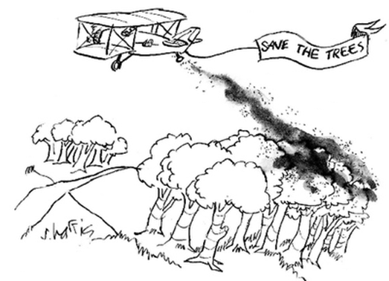

http://ecodot.com/shoppingcart/pages.php?pageid=196
________________________________________________________________________________________________________________________________________________________________________________________________________________________________________________________________________________________________________________________________________________

