Lesson 7
For & Against Paragraph

Goal: Gain argumentative skills
Objectives:
- Learn about the for/against organization pattern
- Write a paragraph taking a position either for or against a human activity which is disrupting the environment

Argumentative Paragraph
One type of paragraph is the argumentative paragraph. The argumentative paragraph allows writers to pick one topic of controversy and argue for or against the issue. In short, this type of paragraph allows the writer to take a solid stand on a particular issue. Your aim in this type of writing is to take a solid stand and pick one side of the issue. You want to convince the reader that you are firm in your argument.
Take some time to think about a simple element that you want to argue. Once you decide what you want to argue about, be sure to think of at least three words that best tell why you are for or against this issue.

(Adapted from: Teaching the iGeneration © 2010 Solution Tree Press • solution-tree.com)

Linking Devices often found in this type of paragraph include:
To introduce points:
The argument that the construction of big hydropower plants should be encouraged is convincing for the following reasons. Firstly, (…)
On the other hand, it could be argued that large hydropower plants cause social and environmental damage. ( …)
To conclude:
Taking everything into account, it can be stated that (…)

Sample of a For-Against Paragraph
Pre-writing Task 1: Clustering “Should large Hydropower schemes be banned?”

Pre-writing Task 2:  Read “Should large Hydropower schemes be banned?” | 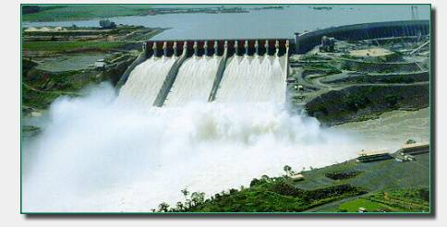  http://www.folkecenter.net/gb/rd/wave-energy/hydropower/
The argument that the construction of large hydropower schemes should be encouraged is convincing for the following reasons. Firstly, it could be argued that energy generation is important to the development of regions. Furthermore, once a dam is constructed, electricity can be produced at a constant rate. Dams are designed to last many decades and so can contribute to the generation of electricity for many years. Moreover, the lake that forms behind the dam can be used for water sports and leisure. Often large dams become tourist attractions in their own right, generating important incomes for local people. The lake's water can also be used for irrigation purposes which helps develop farming. When in use, electricity produced by dam systems does not produce greenhouse gases, i.e. hydropower power does not pollute the atmosphere. On the other hand, it could be argued that large hydropower plants cause social and environmental damage. Firstly, the flooding of large areas of land means that the natural environment is disrupted. Landscape is destroyed; and biodiversity is irreversibly lost. Secondly, people living in areas to be flooded, must move out. This means that they lose their farms and jobs. However, taking everything into account, it can be stated that the advantages outnumber the disadvantages. Nevertheless, the serious environmental and social impacts brought about by the construction of large-scale hydro-electric developments should not be overlooked. Actions should be taken to compensate for the damage.
Source: http://www.technologystudent.com/energy1/hydr2.htm

Pre-writing Task 3: Brainstorming & Organizing your ideas
First, think about environmental issues like the one you have read above. Then, choose one of them to write about. After that, organize your ideas in the blank space provided as in pre-writing task 1.

Writing Task: Write a paragraph using the For-Against Organization Pattern studied (about 100 words).

