Lesson 4
Compare-Contrast

Goal: Identify similarities and differences in different environmental phenomena/situations
Objectives:
- Learn about the compare/contrast organization pattern
- Write a paragraph comparing and contrasting similarities and differences of environmental issues

Comparison Paragraph

A comparison paragraph involves comparing (identifying similarities) and/or contrasting (identifying differences). Words often found in this type of paragraph include:

In contrast Meanwhile Likewise While On the other hand
Although Similarly Different from Both Compared with
Instead of Whereas However But

(From: www.teachers.ash.org.au/vsshistory/HistorySkills/2Paragraphs.doc)

Sample of a comparison paragraph

Pre-writing Task 1: Clustering: Renewable and non-renewable energy sources

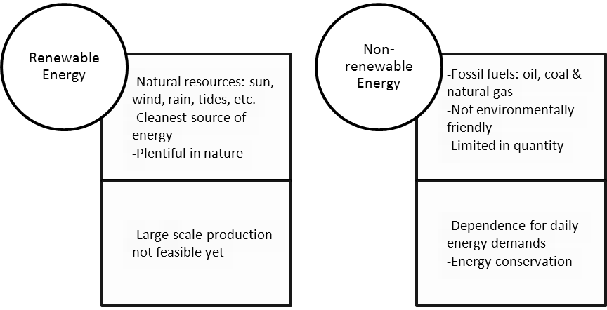

Pre-writing Task 2: Read Renewable and non-renewable energy sources

https://www.iconfinder.com/icons/1951965/energy_green_leaf_plug_renewable_energy_substainable_icon

Renewable energy and non-renewable energy come from different sources. Renewable energy is the energy which is generated from natural sources, such as the sun, wind, rain, tides and can be generated again and again as and when required. They are available in plenty and are, by far, the cleanest sources of energy available on this planet. For instance, energy that we receive from the sun can be used to generate electricity. Similarly, energy from wind, geothermal, biomass from plants, tides could be used to fulfill our daily energy demands. On the other hand, non-Renewable energy is the energy which is taken from the sources that are available on the earth in limited quantity and will vanish fifty-sixty years from now. Non-renewable sources are not environmentally friendly and can bring about serious effects on our environment. They are called non-renewable because they cannot be re-generated within a short span of time. Non-renewable sources exist in the form natural gas, oil and coal. These sources are called fossil fuels. Although the generation of renewable energy is safer and environmentally friendly, its production on a large scale is not feasible yet. As a result, we still depend on non-renewable energy for our daily energy demands, and it needs to be conserved to protect our environment from drastic changes, and to save resources for future generations.

Adapted from: http://www.conserve-energy-future.com/

Pre-writing Task 3: Brainstorming & Organizing your ideas
First, think about energy issues like the one you have read above. Then, choose one of them to write about. After that, organize your ideas in the blank space provided as in pre-writing task 1.

Writing Task: Write a paragraph using the Compare-Contrast Organization Pattern studied (about 100 words).

