Lesson 3
A Process Description Paragraph
Goal: Describe a process
Objectives:
- Identify the process description organization pattern
- Order a sequence of actions to describe a process

What is a process paragraph?
When you explain how to do something or how something happens, you use a process to talk about the steps or events. A process paragraph is a group of sentences that tells this sequence.
A process paragraph consists of a series of connected steps. The steps must be logical and are often chronological in order. You can use time words and transition expressions to make the sequence of events or actions clear. Process writing is especially important when you want to explain the steps necessary to complete a task. Process paragraphs usually demonstrate how to do something.

Process Paragraphs
- Are usually organized chronologically (by time order)
- Follow a logical order
- Give all the necessary steps

Transitions for Process Writing

- To write a good process paragraph, good use of transitional expressions is necessary
- Some common transitions useful for process writing: first, next, then, firstly, secondly, finally, after that, etc.

(Adapted from: http://college.hmco.com/instructors/catalog/walkthroughs/pdf/0618144099_un03.pdf)

Pre-Writing task 1: Outlining. Solar Power System
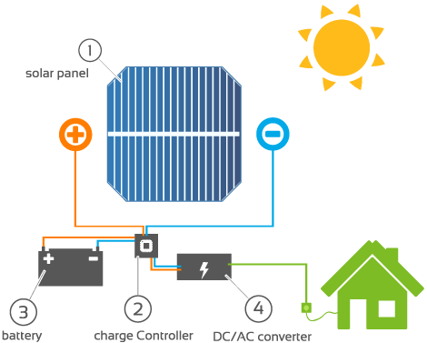
Identify the following steps.

1 Solar panel 2 Charge controller 3 Battery 4 DC/AC Converter
https://www.solarreviews.com/blog/what-equipment-do-you-need-for-a-solar-power-system
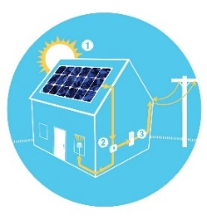
Pre-writing Task 2: Read: Solar Power System

https://www.revisionenergy.com/solar-power-for-your-home/solar-electricity/
How does the solar panel system work? First, the panel converts the Sun’s energy into a DC (direct current) electric current. Second, the current flows to the controller. Then, it can flow from the controller to the lamps. Or it can flow to the battery. The battery stores the electricity. The current can flow from the battery into the lamp through the controller. If the Sun shines, the DC current can flow from the panel, through the controller and into the lamps. If the Sun does not shine, the current can flow from the battery, through the controller and into the lamps. If the lamps are off, the current can flow from the panel, through the controller, and into the battery. The controller controls the flow of the current. Finally, if the battery is full, the controller stops the flow from the panel into the battery. However, if the battery is empty, the controller stops the flow from the battery into the lamps.
Source: Adapted from Technical English 1A

Pre-writing Task 3: Brainstorming & Organizing your ideas
First, think about renewable energy issues like the one you have read above. Then, choose one of them to write about. After that, organize your ideas in the blank space provided as in pre-writing task 1.

Writing Task: Write a paragraph using the process description organization pattern studied (about 100 words).

