Unit 2
Reading comprehension
Skimming, scanning and searching
Efficient readers do not always read every word. To save time, they use techniques like skimming, scanning and searching.
When we skim through a text, we are reading it quickly to get an overall impression of the text.
When we are scanning or searching a text we are looking for specific information which we know, or suspect, is there.

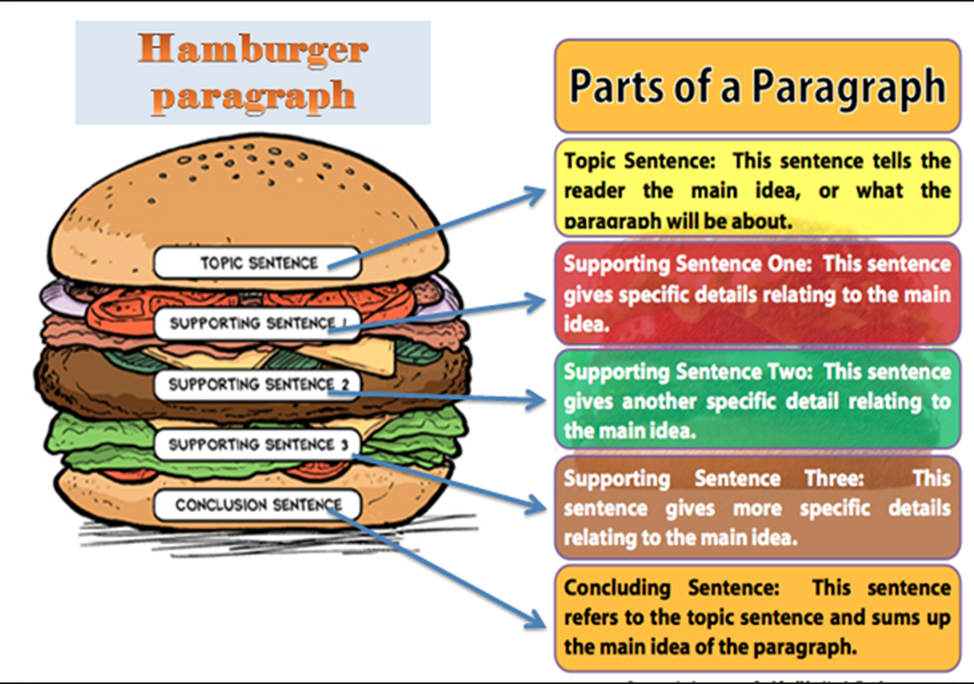
Paragraph structure
Cohesion: cohesive elements
Cohesion refers to the “non-structural text-forming relations” (Halliday and Hasan ,1976: 7). The concept of cohesion in text is related to semantic ties or “relations of meanings that exist within the text, and that define it as a text”.
Without semantic ties, sentences or utterances would seem to lack any type of relationship to each other and might not be considered text.

References
To prevent the same word more than one time in a sentence or in some sentences of the same paragraph or of the same article, writers always use references. References are words that substitute for other words or phrases. They usually refer back to ideas that have already been expressed, but they can occasionally refer forward to ideas yet to be stated. Thus, in order to see the connection between items of information, we need to find the reference of the substitution word. Below is a list of the most often used references. Study them and look at the examples and exercises that follow.
1. Personal pronouns: I, me, my, mine, she, her, hers, he, him, his, it, its, they, them, their, we, us, our, ours, you, your, yours (replace nouns)
2. Impersonal pronouns: one, ones (replace nouns)
3. Demonstrative pronouns: this, that, these, those (replace nouns, phrases, or sentences that refer to a fact or idea)
4. There, then (replace adverbials of place or time)
5. Such + noun (replaces the description of the person or thing named by the noun)
6. The former, the latter, the same (replaces the previously mentioned person, thing, or idea)
Connectives
In order to connect ideas to one another within a sentence, paragraph or passage and to indicate direction of thought, authors frequently use a type of word called connectives (sometimes called directional or signal words). These words signal or clue the reader about what will come next in the sentence, paragraph or passage. Directional words can indicate that a new or different idea will be introduced, that an example will follow, or that an author will present additional information on the same topic.
To see the use of connectives, read the following sentences. Notice the underlined connectives in each.
(1) To sum up, Aristotle taught that all motions resulted either from the nature of the moving object or from sustained push or pull.
(2) There is never only a single force in a situation. For example, in walking across the floor, we push against the floor, and the floor in turn pushes against us.
(3) In other words, in an economic sense the family was an almost self-sufficient unit.
Your reading will be more efficient and meaningful if you are aware of the connectives that link ideas into some kind of relationship. These words or phrases connect ideas together to indicate cause, result, purpose, contrast, similarity, addition, condition, repetition, summary, or specific reasons or illustration. Connectives are useful clues that will help you read more rapidly; therefore, a little practice in recognizing them will be useful. If the meaning of any of the following connectives is unfamiliar, check your dictionary for a complete definition and examples.

Functions | Items
to indicate cause | as, since, because, due to, for, owing to, causes, brings about, leads to
to indicate results or consequences | Therefore, thus, hence, consequently, accordingly, for this reason as a consequence, so, so …..that.
to indicate purpose | in order to, in the hope that, to + verb, so as to, so that
to indicate similarity | Similarly, in the same way, like, as, as …..as, just as …..as,  both …..and, neither…..nor, likewise
to indicate repetition | again, as we have said, it has already mentioned, it has been noted, to reiterate
to indicate time | sequence first, second, finally, then, next, later, before, presently,  subsequently
to indicate order of importance | first, second, primarily, secondarily
to indicate contrast | although, even so, all the same, nevertheless, however, still, but, still, yet, on the other hand, on the contrary, in spite of that fact, despite that fact, unlike, to be sure, instead of.
to indicate addition or continuation  development of idea already  introduced | and, again, in addition, likewise, also, too, as well as, moreover, furthermore, not only….but also, besides, above all, similarly, in the same way, in the same token
to indicate condition | if, unless, on condition that, provided
to indicate summary | in summary, in conclusion, in brief, in short, on the whole, to sum up, finally, ultimately.
to indicate specific reason / illustration | in support of, for example, first, first of all, as an example, for instance, to illustrate.

Substitution
Whereas reference functions to link semantic meanings within text, substitution differs in that it operates as a linguistic link at the lexico grammatical level. In Bloor and Bloor (1995: 96), substitution and ellipsis is used when “a speaker or writer wishes to avoid the repetition of a lexical item and is able to draw on one of the grammatical resources of the language to replace the item “. Unlike reference, substitution is a relation between linguistic items such as words or phrases. Reference is a semantic phenomenon; substitution, including ellipsis, is grammatical.
The three types of classification for substitution identified by Halliday and Hasan: nominal, verbal and clausal, reflect its grammatical function.
In nominal substitution, the most typical substitution words are “one and ones” and they substitute nouns. i.e.
- My axe is too blunt. I must get a sharper one. (one substitutes the noun axe)
In verbal substitution, the most common substitute is the verb “do” and is sometimes used in conjunction with “so” as in “do so” and substitute verbs i.e.
- A: You think Joan already knows؟
- B: I think everybody does. (does substitutes the verb knows)
Clausal substitution unlike the two preceding substitution types, nominal substitute ‘one’- which always operates on the nominal group, and verbal substitute ‘do’- which always operates on the verbal group, clausal substitute ‘so’ and the negative form ‘not’ operate on the entire clause i.e. they do not presuppose a noun or a verb but the entire clause, as in:
- Is there going to be an earthquake? - It says so.
- Has everyone gone home? - I hope not.
In the above examples, it can be seen that the clausal substitute ‘so’ in the second sentence of example (a) presupposes the whole of the clause ‘there’s going to be an earthquake’, and in (b) the negative form ‘not’ in the second example presupposes the whole of the clause ‘everyone gone home ‘.

Ellipsis
An ellipsis is a punctuation mark made up of three dots (...). An ellipsis is used:
- To show an omission of a word or words (including whole sentences) from a text. For example: what good fortune...that people do not think.
- To create a pause for effect. For example: then is appeared...the solution
- To show an unfinished thought. For example: I know he was right, but...
- To show a trail off into silence. For example: we were now on our own...
Synonym
A synonym is a word, morpheme, or phrase that means exactly or nearly the same as another word, morpheme, or phrase in a given language. For example, in the English language, the words begin, start, commence, and initiate are all synonyms of one another: they are synonymous. i.e.
- A: I put the boxes over there.
- B: Please take the boxes and place them in the store room
Writing a Formal Email
In the information age, email has become the dominant form of communication. Being able to write a polished, professional email is now a critical skill both in college and the workplace.
Below are some key distinctions between formal and informal writing, as well as some guidelines to follow when composing a formal email to a superior (professor, current or prospective employer, etc.) or someone who does not know you.
Informal vs. Formal
Informal:
• Written to friends and family
• Accuracy and grammar (spelling and punctuation) are not important
• You can make up your own rules
Example:
Hi Anne,
I miss you so much! Can’t wait to see you on Friday!! We haven’t hung out in so long! I miss my bestie! Maybe we can go to the movies or dinner or just chill and watch TV and catch up…idc, whichever you want.
Love ya,
Jules

Formal:
• Written to a professor, colleague, boss, etc.
• Must always be professional
• Accurate grammar, punctuation, and spelling necessary
Example:
Dear Professor Johnson,
I was unable to attend class today due to a doctor’s appointment. When you have a moment, could please let me know what I missed and what homework I need to have completed for Friday?
Thank you,
Julia Smith

Email Format:
Salutation:
The salutation of a formal email is similar to the salutation of a letter. When writing to someone you do not know by name, you put “To Whom it May Concern.” When applying for a job, you would address the person by, “Dear Hiring Manager.” If you do know the recipient’s name, you put “Dear Mr./Ms. Smith.” For a formal salutation, you should not use the recipient’s first name or the informal greetings “Hello” or “Hey.”
Body Paragraphs:
It is important to remember that an email needs to be concise. The first sentence, known as the opening sentence, can be a greeting if the situation allows it.
• I hope all is well with you.
• Thank you for your prompt response.
However, for most formal emails it is best to get straight to the point. Depending on the subject, you should have a maximum of four paragraphs and each paragraph should contain a single point. It is also important to provide questions in order to prompt a response. At the end of your last paragraph you should provide a “thank you” or “call to action” depending on the subject of your email.
• Thank you for your assistance with…
• Thank you for your time and I look forward to hearing back from you.
• Please feel free to call or email me if you have any questions.
• I would appreciate it if this could be taken care of promptly.
Closing:
Like the salutation, the closing of a formal email can be the same as the closing to a letter.
However, unlike the salutation, there are more options for a closing.
• Thank you
• Best regards
• Sincerely
• Yours
The closing is then followed by your full name. It is also beneficial to add your job position (if applicable) and phone number under your name in the 4th paragraph.
Example:
Sincerely,
Julia Smith
Student Body President
Menlo College
(555) 555-5555
Tips:
• Do NOT use contractions. For example: don’t, haven’t, I’m, isn’t.
• Do NOT write in all capital letters.
• Use formal vocabulary and sentence structure. Do NOT use slang.
• Proofread the email at least twice and get a second opinion if possible.

Request for Quotation
When you’re looking to buy an expensive product or to contract a service, you often want to shop around for the best price. You need to write a quotation request.
That means you have to request a quote from several different suppliers to find the best price for what you want. But how do you ask for a quote?
Usually, it’s easiest to email the company you want the quote from. This is for two reasons:
You can send them exactly what you want and need in written form. That way there’s no room for confusion.
You’ll have the price quote written down so that they can’t change the price later (unless you change what you want, of course).
Quick tips for requesting a quote:
- Be as specific as possible
- Give as many details as you can
- Be concise
- Be formal but polite
How to start an email requesting a quote
To start an email to a company, it’s best to be formal and polite. If you happen to know the name of the person you’re contacting, you can use:
- Dear Mr. or Mrs. ______,
However, if you’re simply asking for a quote, you don’t need to do lots of research into who works at the company in order to find out their name. Therefore, it would be perfectly acceptable and polite to use:
- Dear sir/madam,
- To whom it may concern,
The main body of your email requesting a quote
When requesting a quote, you need to tell the people you’re emailing exactly what you’re asking for in a clear, precise way:
Here are some example sentences:
- I would like to request a quote for _________.
- I would be interested to know the price of ________.
- Please could you send me a quote for_______.
- Please could you provide me with a quote for ______?
- I would be grateful if you could send me a quote for the following_______.
When you’re asking for a quote, it’s best to let the company know exactly what you want, in detail, so that they can tell you how much it would cost. It is also helpful to find out exactly what the company does, so that you can list the specific services you want a quote for. Give as much detail as possible, but be concise. If relevant, you should include the following information:
For a service:
When you want it
Where you want it
Material required
How long it will take
What the location is like where the service will be carried out

For a product:
- If there are different options, which ones you want specifically
- If / where you want it delivered to
- What you need it for (if appropriate)
Signing off an email requesting a quote
Be polite and formal when you’re signing off an email. You don’t need to be particularly friendly, but if you want to write a sentence at the end about hearing back from the company, you can choose from the following examples:
- I hope to have an early response from you.
- Hope to hear back from you soon.
- Looking forward to hearing back from you.
Then you need to sign off the email with a sign-off and your name. Here are some options:
Formal:
- Yours sincerely,
- Sincerely,
- Regards,
- Warm regards,
Less formal:
- Best,
- Best wishes,
- Many thanks,
- With gratitude,
- Thanks in advance,
- I appreciate your help on the matter,

- Sample: Request a quote
Dear Sir/ Madam,
I would like to request a quote for a _________. I have seen that your company sells several different models, but since I need it to ______ and ______, I feel the __________ would be the most appropriate.

I would also want to know how long it would take to ship the _______ to [place where you live].

- Sample e-mail asking for a price quotation
Honored,
Through this email, I wish to formally request a price quotation for a selection of goods from your esteemed company. I am the project manager for Doe Ltd. And we are working on a new building that would benefit from using your products.
We wish to buy in bulk, so please add any bulk offers you provide.
The items in question are:
(detailed list of times here)
In case you require any further information, or due to company policy we need to fill out a quotation form, do not hesitate to contact me.
I look forward to hearing from you and possibly doing business in the future.
Best,
John Doe, project manager

