**Job Interview**

If your resume provided a good impression, the employer will ask you to complete the following step which is the job interview.

As a general rule, a job interview is an important part of the process of applying for a job and it consists in a conversation. This exchange may range in formality from a casual conversation to a series of serious discussions between a job applicant and a potential employer or with an assortment of people working within the company.

During the job interview, the employer has the opportunity to appraise applicant’s qualifications, appearance and general fitness for the job opening. It is wise to prepare for a job interview. Here are some tips and possible questions to consider during an interview.

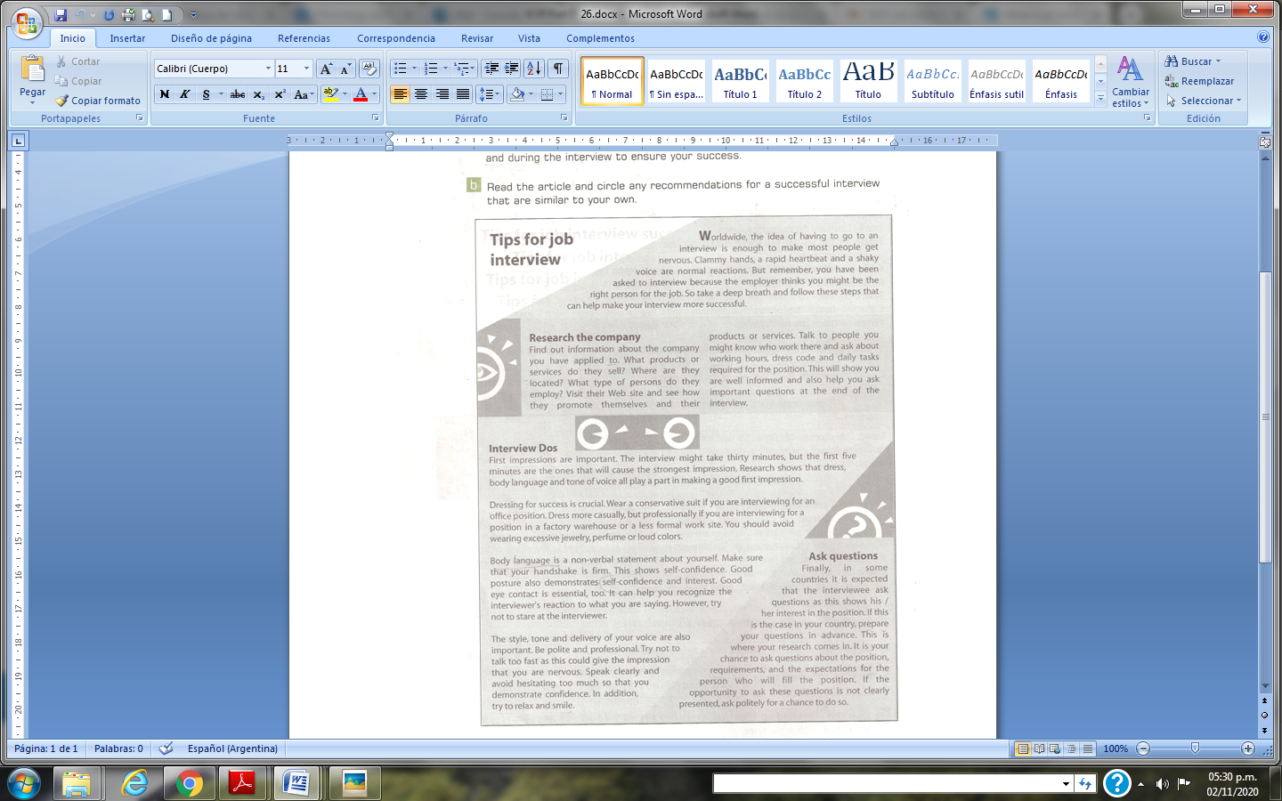

Questions you are most likely to be asked in a job interview:

1. Tell me about yourself (provide an overview of who you are as a professional).
2. What interests you about this opening? (Or why do you want to work for us?)
3. What do you know about our company so far?
4. Why did you leave your last job? (Or why are you thinking about leaving your current job?)
5. Tell me about your experience at ___. (Fill in past job.)
6. What experience do you have doing ____? (Fill in each of the major responsibilities of the job.)
7. Tell me about your strengths.
8. Tell me about a difficult time and how you overcame it?
9. 9. What salary range are you looking for? (Most lines of work have a set salary range and it would be wise to learn what this range is prior to the interview. If you are unable to obtain this information, you may want to tell the interviewer that you would work for whatever the company feels is fair, based on your qualifications and the company's standard salary level for that position. If you want to request a specific salary, be able to back up why you should get that amount - avoid stating personal reasons.)
10. What questions do you have for me? Here are 10 questions to consider asking:
11. Why is this position open?
12. What are the biggest challenges or obstacles the person in this position will face?
13. Can you describe a typical day or week in the position?
14. What would a successful first year in the position look like?
15. How will the success of the person in this position be measured?
16. Thinking back to the person whom you have seen do this job best, what made his or her performance so outstanding?
17. How would you describe the culture here?
18. How would you describe your management style?
19. Are there reservations you have about my fit for the position? (This is a great way to give yourself the chance to tackle any doubts they might have about you)
20. When do you expect to make a hiring decision?

Homework

Watch the interview clip taken from the film “The pursuit of happyness”. Then in this week´s FORUM discuss the Do´s and Don´ts for a job interview.