Facultad de Ingeniería -Técnico en Mantenimiento Industrial

Name:
Date:
Test 1 (Mock Exam)

- HAND TOOLS
Circle the odd word out
washers steering wheel bolts spanner
screwdriver nails hammer elbow
skateboard pliers saw shovel
chisel car scissors screws
drill funnel forklift truck level

- MAKE SENTENCES ABOUT THE LOCATION OF:

- mouse 2. computer 3. right-hand speaker 4. left-hand speaker 5. Keyboard 6. screen
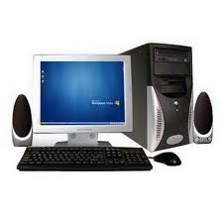
- … …………………………………………………………………………………………
- ……………………………………………………………………………………………
- ………………………………………………………………………………………………
- ……………………………………………………………………………………………
- ………………………………………………………………………………………………
- ……………………………………………………………………………………………..

- ACTIONS
How to start a car: Read the instruction (a-h) for starting a vehicle. Put the sentences into the correct order.
- press down on the clutch pedal, again
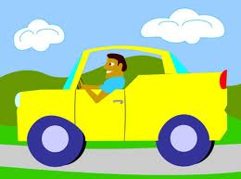
- fasten your seatbelt
- twist the key using your fingers and the car starts
- get into the vehicle
- change into first gear and you are ready to go
- insert the key into the ignition barrel
- change into neutral gear
- Press down on the clutch pedal

Flow: How Does Wind Energy Work?
The diagram below shows a simplified version how a wind turbine converts the kinetic energy in the wind to electrical energy.

Complete the text explaining how kinetic energy in the wind is converted into electricity. Circle the correct verb

The wind (blows/flows) on the blades and makes them (fly /turn). The blades (pull/turn) a shaft inside the nacelle (the box at the top of the turbine). The shaft (goes/opens) into a gearbox which (increases/reduces) the rotation speed enough for the generator, which uses magnetic fields to (convert/move) the rotational energy into electrical energy.

D- Instructions
Read the text and follow the instructions.
Start at the red triangle. Move sideways three boxes to the right. Go diagonally up one box to the right. Move horizontally eight boxes to the left. Descend three boxes. Go diagonally up two boxes to the right. Move diagonally down two boxes to the right. Where are you? Circle the item you arrive at the end.

How does a thermosiphon work? Complete the text using the words from the box.
stays - rises - valve –inlet - flows – heat – passes – tank - open – outlet – enters - warm water - panel – tank- flows – pushes

- First, the cold water______________ the system through the_________.
- The water pressure ______________the water around the system.
- Then, it ___________ into the panel and the sun´s rays ____________it. The____________ __________ _________to the top of the ___________ and it ___________ from the panel into the __________.
- The hot water ______________ at the top of the ___________.
- If you __________ the __________, the hot water _____________ from the top of the tank to the __________.

E- Assembling.
How to Assemble a Bike. Identify the parts.

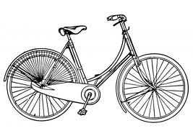
Handlebar tyres seat frame pedals fork reflectors wheel spokes front brake

Complete the instructions using the following words:

slide (2) – adjust (2)– tighten (2) – straighten – put – attach –
pull – lift – spin -
- _______________ the handlebars onto the frame.
- ________________ the height of the handlebars and ____________ the bolt just until it won't move. You'll need to ______________the handlebars after the front tire is on and then tighten the bolt all the way.
- ___________ the seat post into the bike frame if not already installed. __________ the height, check that it's straight.
- _______ the front tire on the forks.
- Straighten the wheel.
- _________ the reflectors to the wheel spokes with a screwdriver.
- _________ the pedals and __________ the bolts.
- ________ the front brake several times. _________ the bike and ________ the front wheel to make sure it spins freely.

