Lesson 4

Writing the Introduction and Conclusion of the Scholarship Essay

Your essay lacks only two paragraphs now: the introduction and the conclusion. These paragraphs will give the reader a point of entry to and a point of exit from your essay.

Introduction | 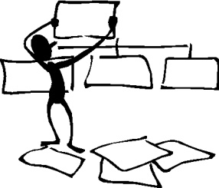

Consider the people who are reading your essay. They could be reading hundreds of essays! If you want to get their attention, you have to do it in the introduction. How can you spark their interest so they want to read on? You can do this by beginning with an attention grabber (startling information, anecdote, summary information, etc). In other words, the introduction should be designed to attract the reader's attention and give her/him an idea of the essay's focus.

The introduction should be about four sentences long including the attention grabber and sentences that will lead the reader from your opening to your thesis statement. The introduction paragraph should finish with your thesis statement.

Conclusion

The conclusion brings closure to the reader, summing up your points or providing a final perspective on your topic. All the conclusion needs is three or four strong sentences which do not need to follow any set formula. Simply review the main points (being careful not to restate them exactly) or briefly describe your feelings about the topic. Even an anecdote can end your essay in a useful way.

Your conclusion is your last chance to show why you deserve this scholarship—but don’t summarize everything you have just said. Often the scholarship essay is short, so do not keep repeating things you just said a paragraph ago.

The introduction and conclusion complete the paragraphs of your essay.
Don't stop just yet! One more step remains before your essay is truly finished.

Now write the introduction and conclusion paragraph of your scholarship essay.
Once you have finished, check with your partner. Does the introduction paragraph catch your attention? Does the conclusion paragraph end the topic correctly? What suggestion could you provide to improve these paragraphs?

