TECHNOLOGY today
__________________________
__________________________
- Efficiency and Productivity One of the most significant advantages of technology is the boost in efficiency. Tasks that once took hours, if not days, can now be completed in mere minutes. In civil engineering, modern technology has given rise to machines that handle tasks like concrete mixing and even foundation construction, streamlining these essential processes.
Advanced Technology compressing concrete.
- __________________________ Technology has transformed the way we communicate. With the advent of the internet and smartphones, we can connect with people worldwide at the touch of a button. This has not only made the world a smaller place but has also facilitated global collaboration, knowledge sharing, and real-time communication. Consider EIT as an example. Today, online tudents attend webinars where the lecturer may be from Spain, Turkey, or even the USA. This level of global connectivity and accessibility would have been unimaginable centuries ago.

- Automation: Automation has been a game-changer for various sectors. Manufacturing, engineering, logistics, and agriculture, among others, have benefited from automated processes, reducing the need for manual labor. This results in increased precision, consistency, and a reduction in workplace injuries. For example, Computer-Aided Design (CAD) is used in many engineering fields such as Mechanical, Electrical, Civil, Electronics, etc and is a software accelerates the design process and minimizes errors.

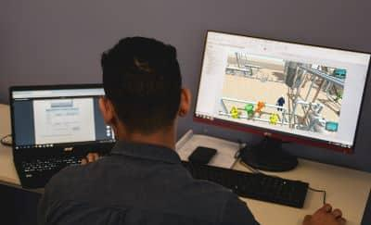
- _____________________ Technology has expanded the horizons of education. E-learning, online courses, and educational apps have made learning more interactive and accessible. For instance, a student pursuing a degree in Mechanical Engineering can enroll in an online course with EIT, that offers in-depth webinars, course material, online libraries and remote labs.

__________________________

- _____________________ Automation, artificial intelligence, and robotics have the potential to replace many jobs. In the field of engineering, automation and robotics are transforming the manufacturing and assembly processes. However, with the introduction of advanced robotic arms and automation systems, these tasks can now be performed with greater precision and efficiency.
- Social Isolation The increasing reliance on technology for communication has the potential to isolate individuals. Face-to-face interactions are reduced, and there’s a risk of reduced social skills and increased feelings of loneliness. While this has expanded the reach of communication, it has also led to changes in how individuals interact.
- ____________________ Excessive screen time and technology use can lead to various health issues. These may include digital eye strain, poor posture, physical inactivity, and even addiction to technology. Moreover, the sedentary nature of technology use can contribute to physical inactivity, which is associated with various health problems, including obesity and cardiovascular issues.
Technological advancement is a double-edged sword. While it has unlocked tremendous opportunities and improved our quality of life in many ways, it also presents challenges and potential drawbacks. Striking a balance and addressing these issues is essential to maximizing the benefits of technology while mitigating its negative consequences. It’s an ongoing conversation that continues to shape our modern world.
ACTIVITIES
- Provide two subtitles for each section
- Choose from the following chart and place the subtitles in the right place.
PROS | CONS
Education Revolution  Communication Revolution | Health Concerns  Job Displacement

- Identify as many transitional devices as you can.
- After reading the text, decide where the conclusion starts and finishes.

