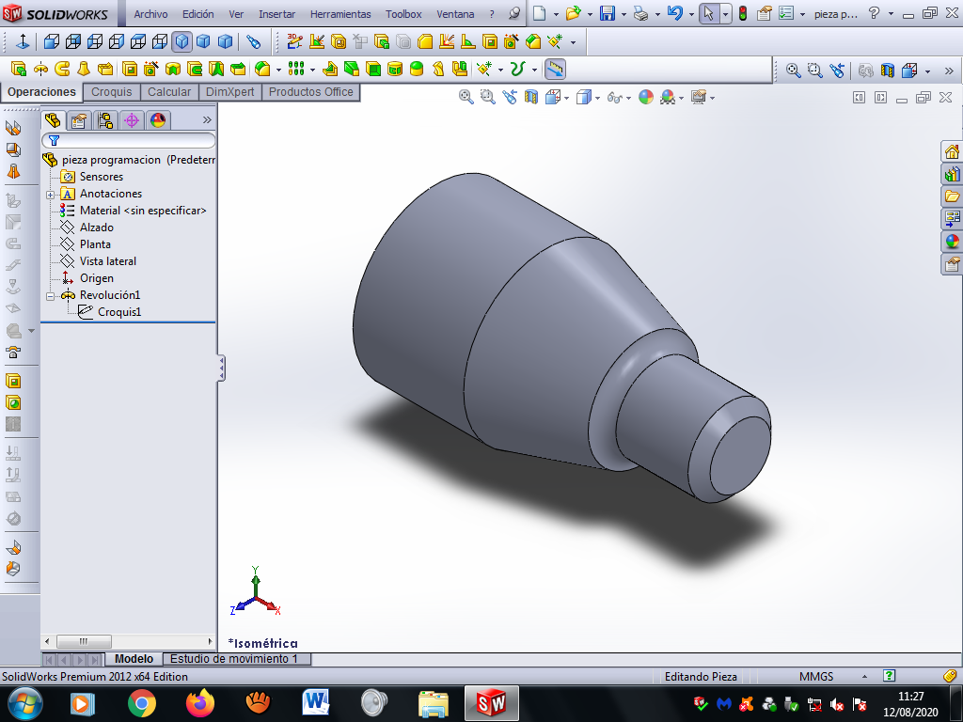

|  |  |  |  |
| --- | --- | --- | --- |
| Puntos | X | Z | R |
| 0 | 0 | 0 | 0 |
| 1 | 26 | 0 | 0 |
| 2 | 30 | -4 | 0 |
| 3 | 30 | -30 | 0 |
| 4 | 40 | -35 | 5 |
| 5 | 60 | -70 | 0 |
| 6 | 60 | -110 | 0 |

