Unit 3: Text interpretation
Text interpretation involves constructing meaning by going beyond the literal information presented in a text. It requires identifying the main ideas, purpose, and relationships between ideas, making inferences, and recognizing the author’s perspective and underlying assumptions. Interpretation therefore involves considering not only what the text says, but also what it means and how its different elements contribute to the overall message.
Interpreting academic texts involves developing a comprehensive grasp of the information, concepts, and arguments presented by the author. This requires identifying the text’s structure, recognizing key terminology and concepts, distinguishing main ideas from supporting details, and following the development of the argument. Effective understanding also involves using reading strategies such as skimming, scanning, selective reading, and self-questioning to process complex information and construct an overall representation of the text.
Understanding papers
Scientific writing is characterized by a highly specific vocabulary, concise and precise language, and often complex grammatical structures. Therefore, comprehending scientific studies can pose cognitive challenges, especially for readers unfamiliar with the field’s terminology. The ability to critically and effectively read a paper is essential. Regular reading can aid in staying current with new research, fostering original ideas, and producing superior papers.
Two aspects are essential for understanding the meaning of a research paper: recognizing its structure and applying effective reading strategies.
- The structure of a research article

Understanding a research paper requires knowing its structure and the purpose of its different sections. Recognizing the function of sections helps readers identify how the research question is presented, how the study is conducted, how findings are reported, and how these findings are interpreted. Familiarity with this structure allows readers to navigate the paper more efficiently and establish connections between its different sections.
An initial overview of the structure of a research article can be observed below:
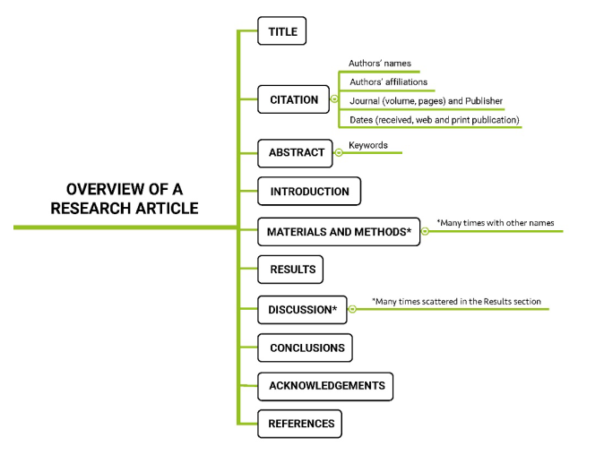
- Reading comprehension strategies for a research paper
A useful strategy for approaching a research paper is Keshav’s (2007) Three-Pass Approach, which proposes reading a paper at three increasingly detailed levels. The first pass provides a general overview of the paper by examining its title, abstract, introduction, section headings, conclusion, references, and visual elements. The second pass involves a more careful reading aimed at understanding the main argument, methodology, evidence, and results, while temporarily setting aside details that are not essential to grasping the overall contribution. The third pass consists of a detailed and critical analysis in which the reader examines the authors’ assumptions, methodological choices, evidence, results, and limitations. This progressive approach encourages readers to move from general comprehension to deeper analysis and critical evaluation without attempting to process every detail of the paper at once.
Three-pass approach (Keshav, 2007), summarized as follows:

̶ Gain a general understanding of the article:
Read the Title, Abstract, and Introduction - Read section and sub-section headings (ignoring other content) - Read the Conclusions - Scan references

Evaluation: This pass should reveal the article’s main highlights; if not, the article may not be worth reading.

̶ Grasp the article's content (but not its details):
Examine illustrations, figures, and graphics - Focus on the quality and statistical significance of the results - Explore references for background information.

Evaluation: The level of detail in this pass should indicate if the article aligns with the desired research specialty.

̶ Understand the article in depth:
Pay close attention to details - Adopt the same assumptions as the authors to recreate the work - Record ideas for future work.

Evaluation: This final pass offers a deep insight into the evidence, discussion, and presentation techniques, and it typically requires much time.

How to Read a Research Paper
Reading research papers effectively is challenging. These papers are written in a very condensed style because of page limitations and the intended audience, which is assumed to already know the area well. Moreover, the reasons for writing the paper may be different than the reasons the paper has been assigned, meaning you have to work harder to find the content that you are interested in. Finally, your time is very limited, so you may not have time to read every word of the paper or read it several times to extract all the nuances. For all these reasons, reading a research paper can require a special approach.
To develop an effective reading style for research papers, it can help to know two things: what you should get out of the paper, and where that information is located in the paper.
Despite a paper's condensed form, it is likely repetitive. The introduction will state not only the motivations behind the work, but also outline the solution. Often this may be all the expert requires from the paper. The body of the paper states the authors' solution to the problem in detail, and describes a detailed evaluation of the solution in terms of arguments or an experiment. Finally, the paper will conclude with a recap, including a discussion of the primary contributions.
Furthermore, it is considered useful to focus on recurring expressions and linking devices that signal the purpose and content of each section. These expressions act as linguistic clues that help readers predict what information is coming next:
Section | Expressions / linguistic signals | What they help the reader identify
Title / Abstract | This paper presents…; This study investigates…; The aim/objective of this study is…; The results show/suggest…; The findings indicate… | Topic, purpose, methods, and main findings
Introduction | In recent years…; There has been increasing interest in…; Previous studies have shown…; However…; Despite…; Although…; Little attention has been paid to…; The aim of this study is…; This paper examines… | Background, research problem, gap, and purpose
Literature Review | According to…; Previous research has found…; Several studies have reported…; Similarly…; In contrast…; However…; These findings suggest…; Building on… | Previous research, similarities, differences, and research gaps
Methods / Methodology | The study was conducted…; Data were collected…; Participants included…; The sample consisted of…; The researchers used…; Data were analyzed using…; To determine…; In order to… | How the research was conducted
Results / Findings | The results show…; The findings indicate…; As shown in Figure/Table…; The data reveal…; There was a significant…; Compared with…; A higher/lower percentage… | Main findings and patterns in the data
Discussion | These findings suggest…; This may indicate…; One possible explanation is…; This result is consistent with…; In contrast to previous studies…; This finding supports…; These results can be explained by… | Interpretation and explanation of findings
Conclusion | In conclusion…; Overall…; This study has shown that…; The findings demonstrate…; The results suggest…; The study highlights…; The main contribution of this study is… | Main conclusions and contributions
Limitations | One limitation of this study is…; This study was limited by…; A possible limitation…; The findings should be interpreted with caution… | Limitations and scope of the research
Future Research | Future research should…; Further studies are needed to…; Future work could focus on…; It would be interesting to investigate…; Further research may examine… | Possible directions for further research

Reading a research paper effectively involves more than identifying its main topic or understanding individual sections. An active reader should approach the paper with specific questions in mind in order to identify the research problem, understand the proposed solution, evaluate the evidence, and reflect on the authors’ contributions. These questions provide a framework for reading critically and systematically, helping readers distinguish the most relevant information from supporting details and develop their own interpretation of the research. The following questions can therefore be used as a guide when reading or skimming a research paper:
Guiding Questions for Reading Research Papers
- What are the motivations for this work? For a research paper, there is an expectation that a problem has been solved that no one else has published in the literature
- What is the proposed solution? This is also called the hypothesis or idea. This is the proposed answer to the research question.
- What is the work's evaluation of the proposed solution? This is the concrete engagement of the research question. Is this a good idea? What flaws do you perceive in the work? What are the most interesting points made?
- What is your analysis of the identified problem, idea and evaluation?
- What are the contributions? The contributions in a paper may be many and varied
- What are future directions for this research? Not only what future directions do the authors identify, but what ideas did you come up with while reading the paper?
- What questions are you left with? What questions would you like to raise in an open discussion of the work? What do you find confusing or difficult to understand? By taking the time to list several, you will be forced to think more deeply about the work.
- What is your take-away message from this paper? Sum up the main implication of the paper from your perspective.

As you read or skim a paper, you should actively attempt to answer the above questions. It can be particularly productive to answer each question in turn, writing down your responses and keeping a record of the papers you read. This practice not only helps you monitor and deepen your understanding of each paper, but also allows you to organize relevant information for future reference. A written record can make it easier to compare studies, identify connections among different papers, trace the development of ideas, and retrieve useful information when writing your own research paper or literature review.

